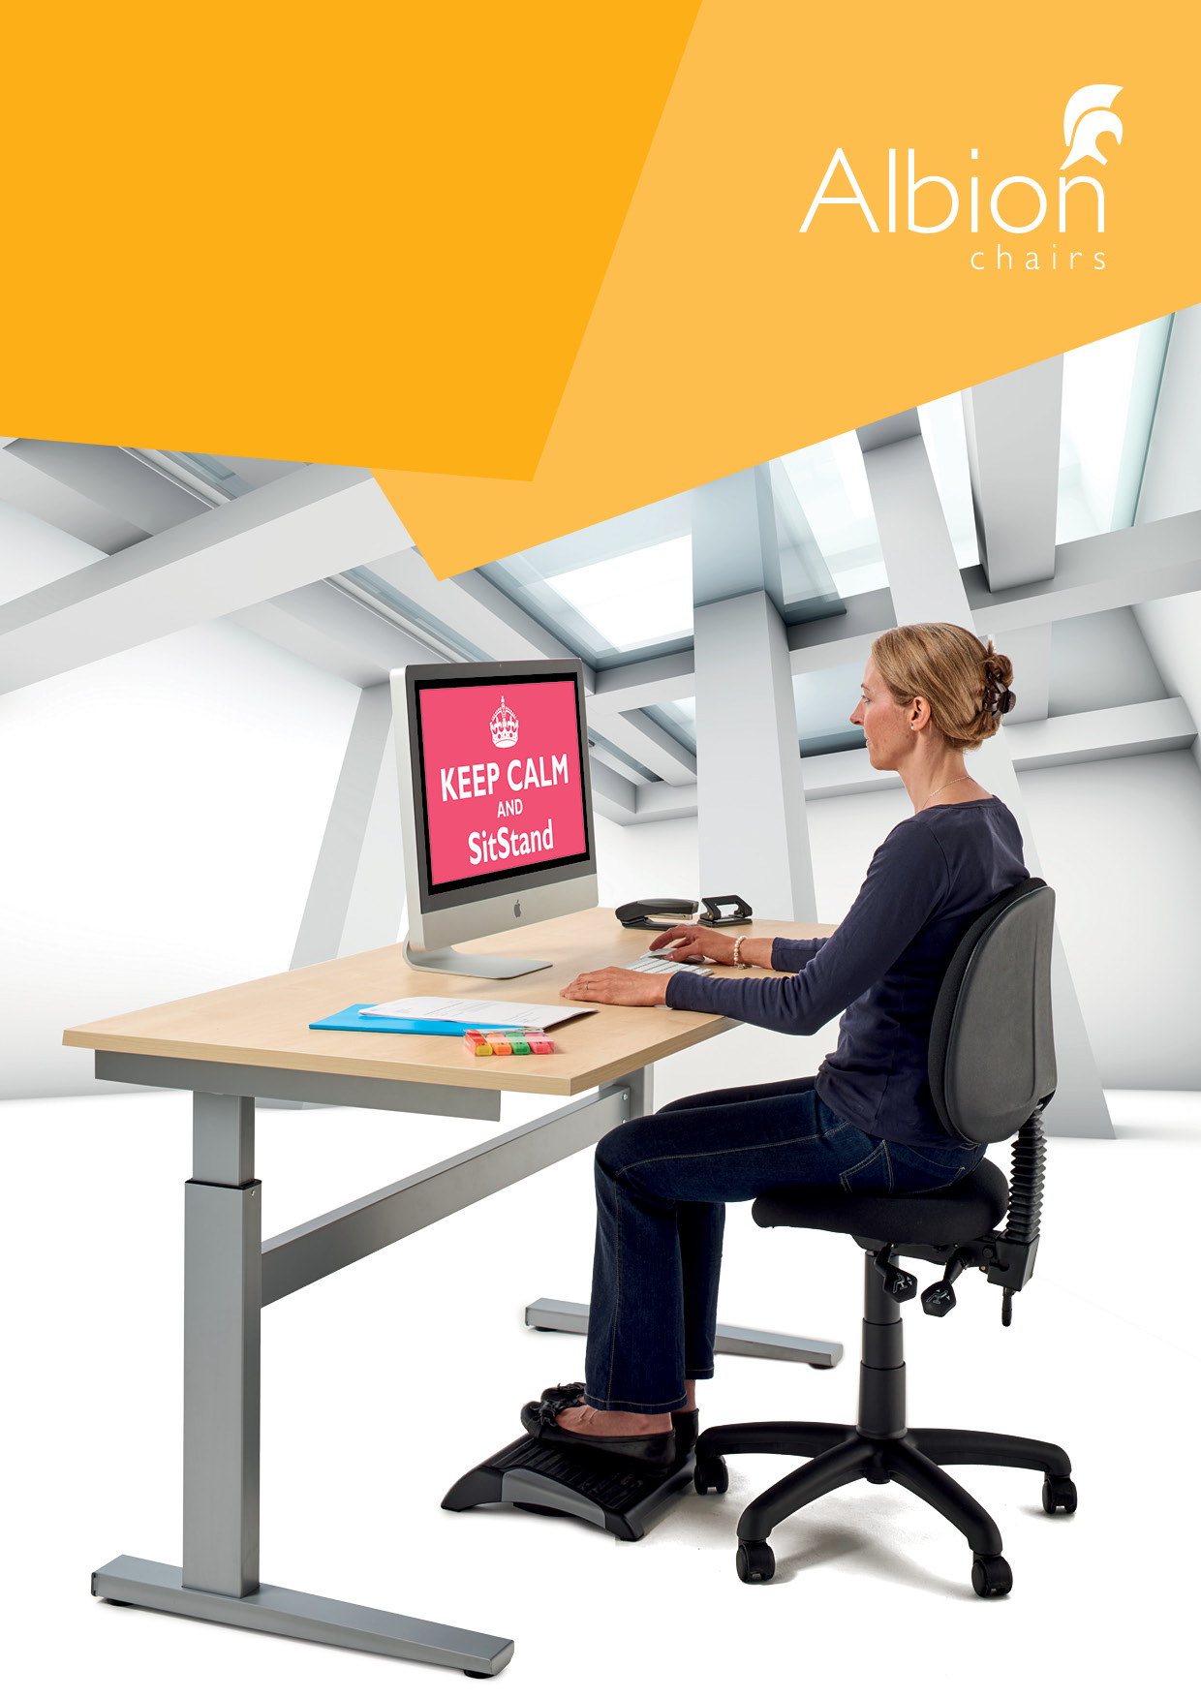

2018

Electric height adjustable SitStand desks

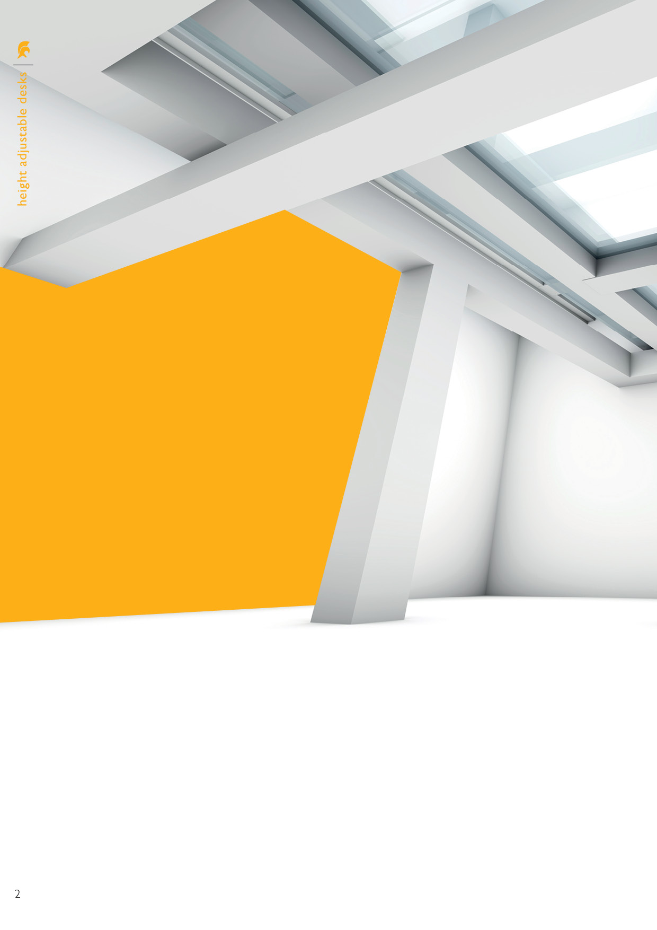

Our electric **SitStand** offering comes in two frame footprints (1200mm and 1600 wide by 800mm deep) and is available in an elegant silver finish. Our desk tops are available in 1200, 1400, 1600 and 1800 x 800mm to suit your requirements. We offer 4 colours: white, maple, light oak and beech. Other colours are available on request.

There are 3 supply options: without top/unassembled, without top/assembled and assembled with a top. The first two scenarios allow you to provide your own top or to reuse the end-users desk top.

We are also able to provide a range of accessories to complement the **SitStand** desks. These include a choice of 3 monitor arms (budget, standard, premium), a sliding/retractable CPU holder, a desk mounted document holder and a couple of footrests. Please note we can also manufacture made to measure foot platforms if required.

As with our chairs, we provide a five year guarantee for the SitStand desks. Both the frame and tops are held in stock. We are also able to provide other tops on a 2 week lead time.

Our **SitStand** desks and accessories can be delivered and installed direct to your end user.

An electric height adjustable SitStand desk allows office and home workers to enjoy the ergonomic and health benefits of both sitting and standing while they work. Using a SitStand desk promotes good blood circulation, prevents problems associated with prolonged sitting and can result in increased alertness and activity levels. It also helps fight fatigue making it easier to focus on work tasks, improving mood, and productivity levels.

# New from Albion

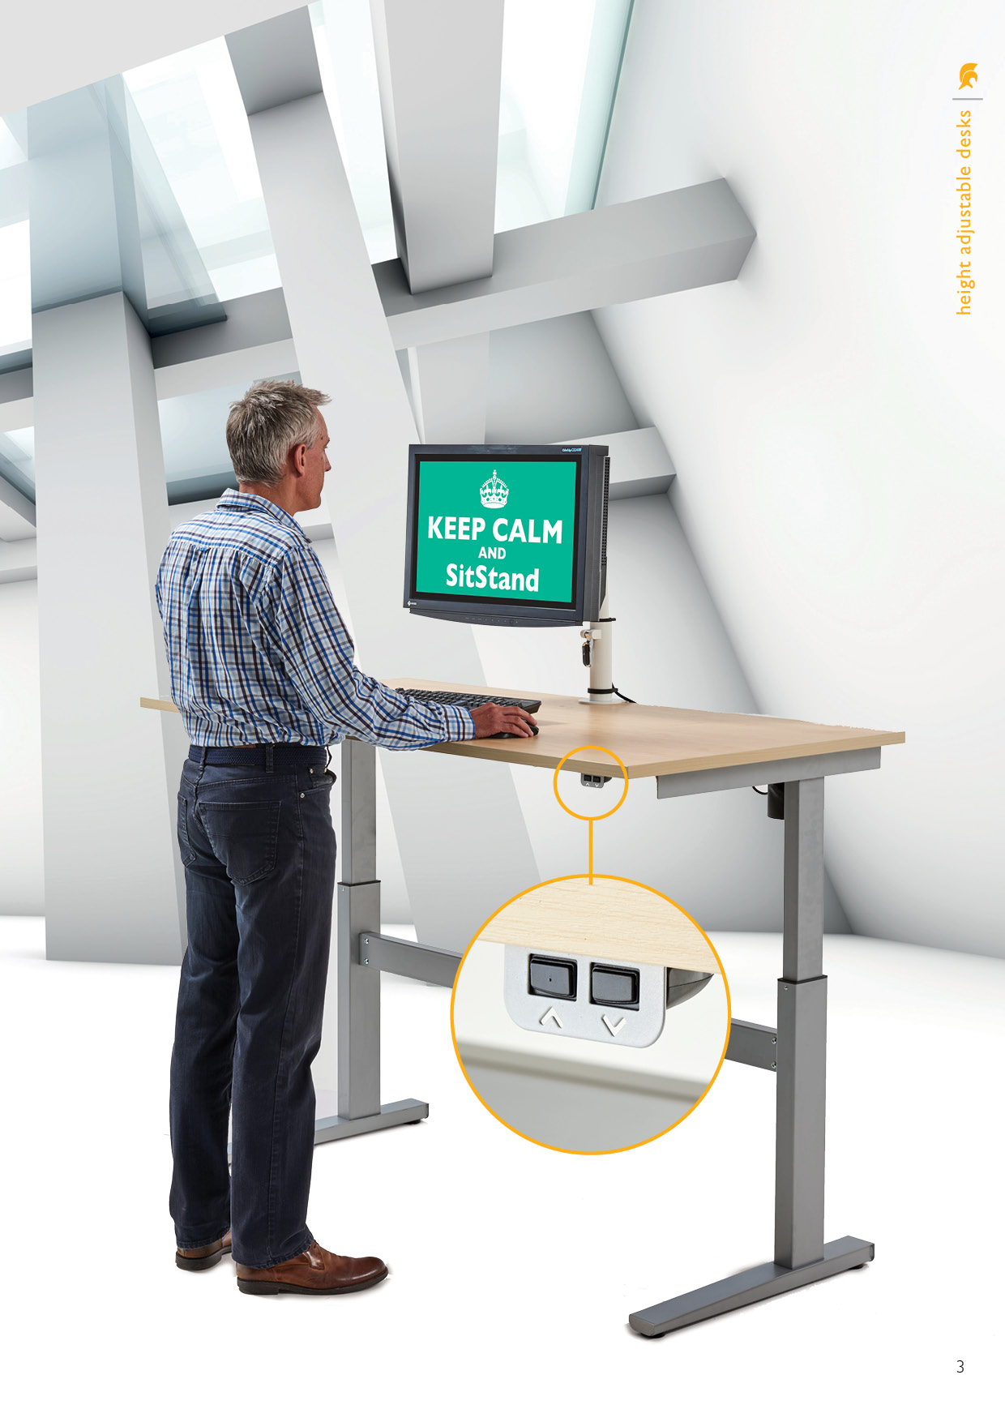

Easy to use mechanism,   
ideally placed so the desk can be adjusted to the required height

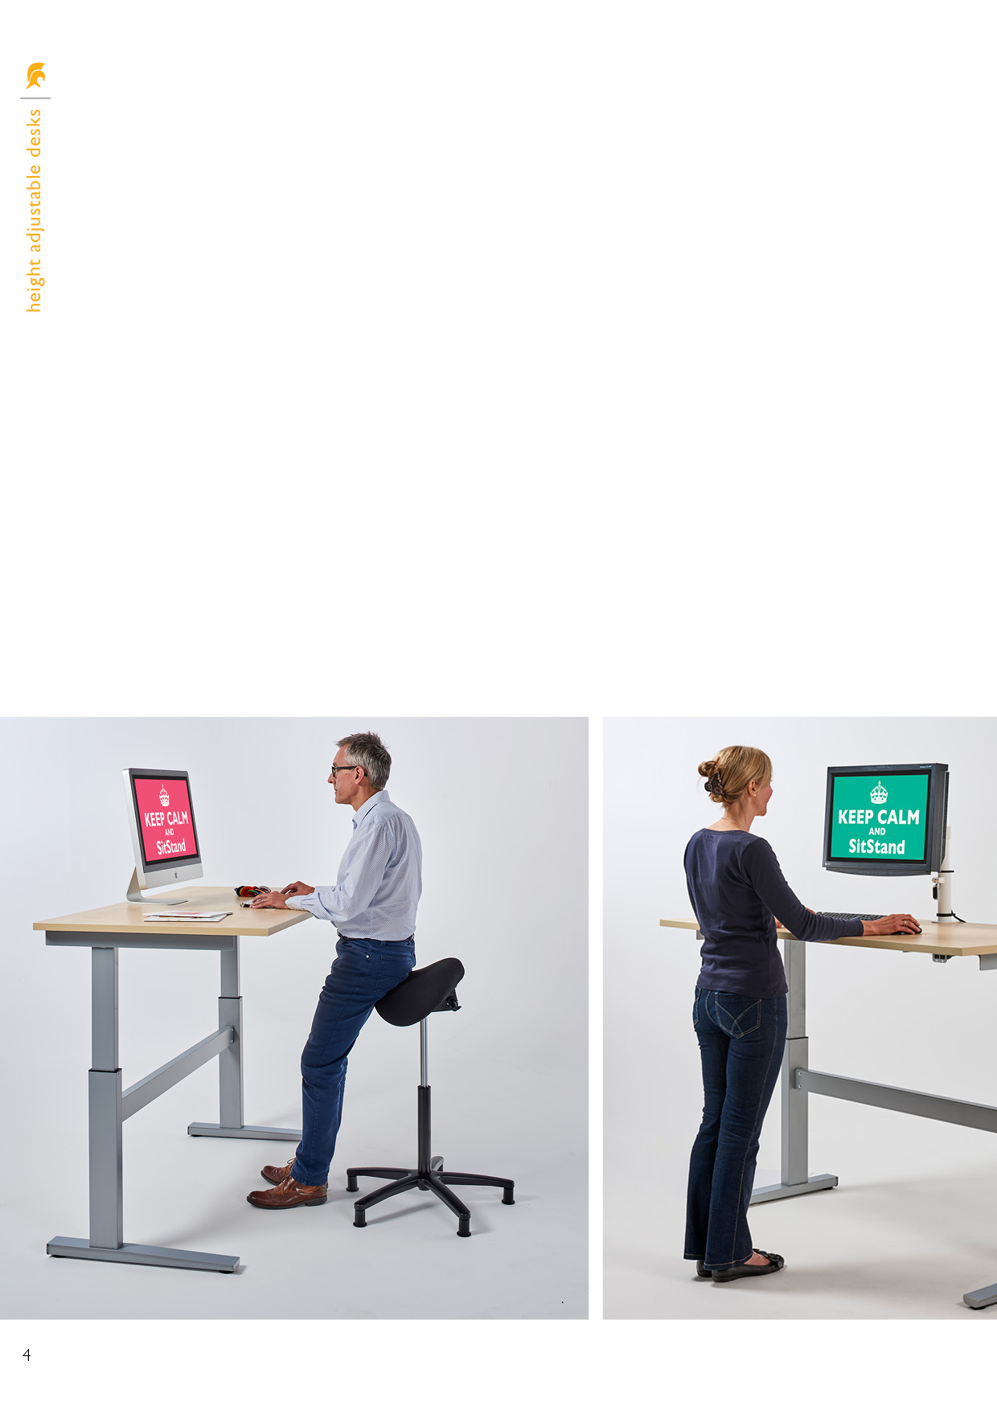

Many studies show that sitting for more than 6 hours a day is linked to being overweight, obese, having type 2 diabetes, some types of cancer and much worse.

With technology such as computers, television and video consoles changing our work and leisure habits, it seems we’re spending increasing amounts of our lives sitting down. There is no doubt this seriously impacting the nation’s health. In fact, one of the largest pieces of research on the topic to date found that a sedentary lifestyle can cause:

* 112% increase in risk of diabetes
* 147% increase in cardiovascular events
* 90% increase in death caused   
  by cardiovascular events
* 49% increase in death from any cause

## Why buy an electric height adjustable SitStand desk…

An electric height adjustable SitStand desk gives you the option to sit or stand throughout the day, keeping your muscles active and reducing the risk of aches and pains caused by repetitive movements.

**Benefits of SitStand Desk**

* Increased alertness, concentration and productivity
* Improved blood circulation
* Relief from muscle ache caused by static posture
* Flexibility to adjust the working position to the task at hand
* Burn more calories

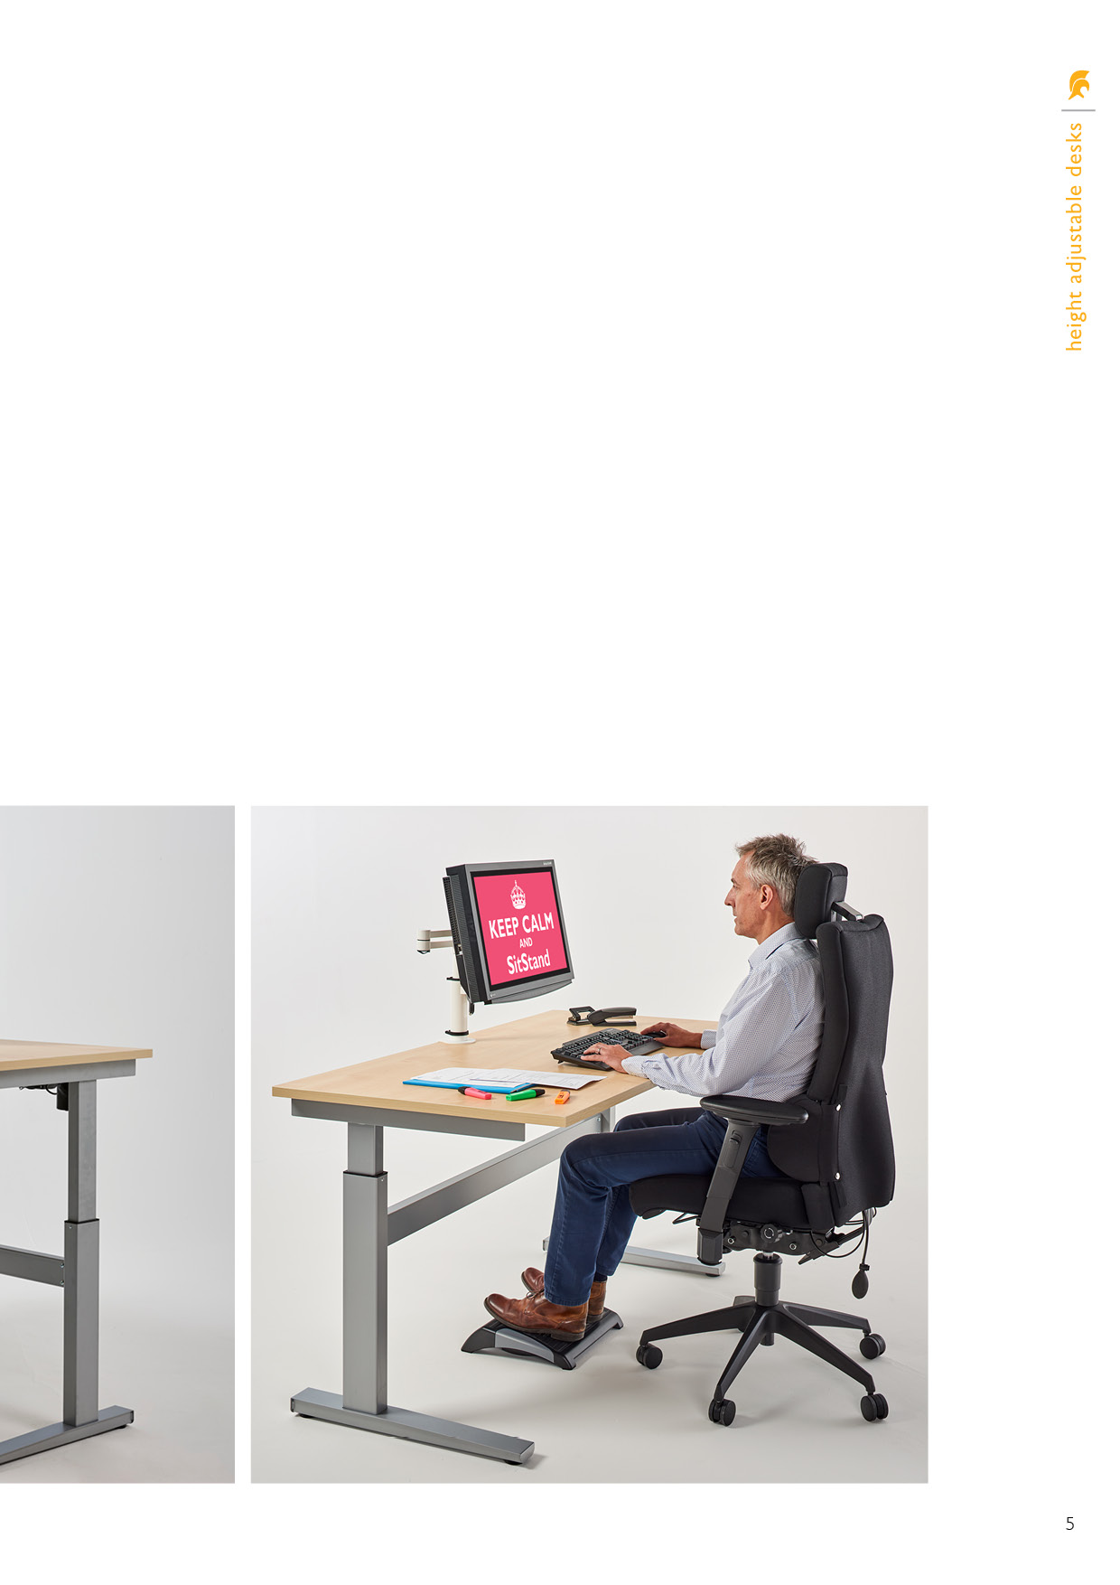

Our SitStand desk comes with a five year   
guarantee, the frame is in stock and the top   
can be provided on a week lead time. We   
do however stock maple, light oak, beech   
and white colour for a 2 week lead time.

Our SitStand desk and accessories can be   
delivered and installed direct to your end user – pricing is dependent on whether we have a bad   
back chair to deliver at the same time or not.

Other Wood colour samples are available upon request, and if you need any help or advice   
planning your space, do not hesitate to call:  
   
**Phil** on **07803 120 155** or   
**Denis** on **07734 467 924**

**Technical specification**

* Input – 240V
* Range of movement (stroke) 400mm: 700mm to 1100mm measured to the underside   
  of the desk top
* Load capacity – 100kgs,   
  max speed 16mm/second
* Duty cycle: - don’t operate for  
  15 minutes for every 15 actions  
  to prevent overheating of motor
* Operation environment: - for indoors – -5~40 degrees Celsius

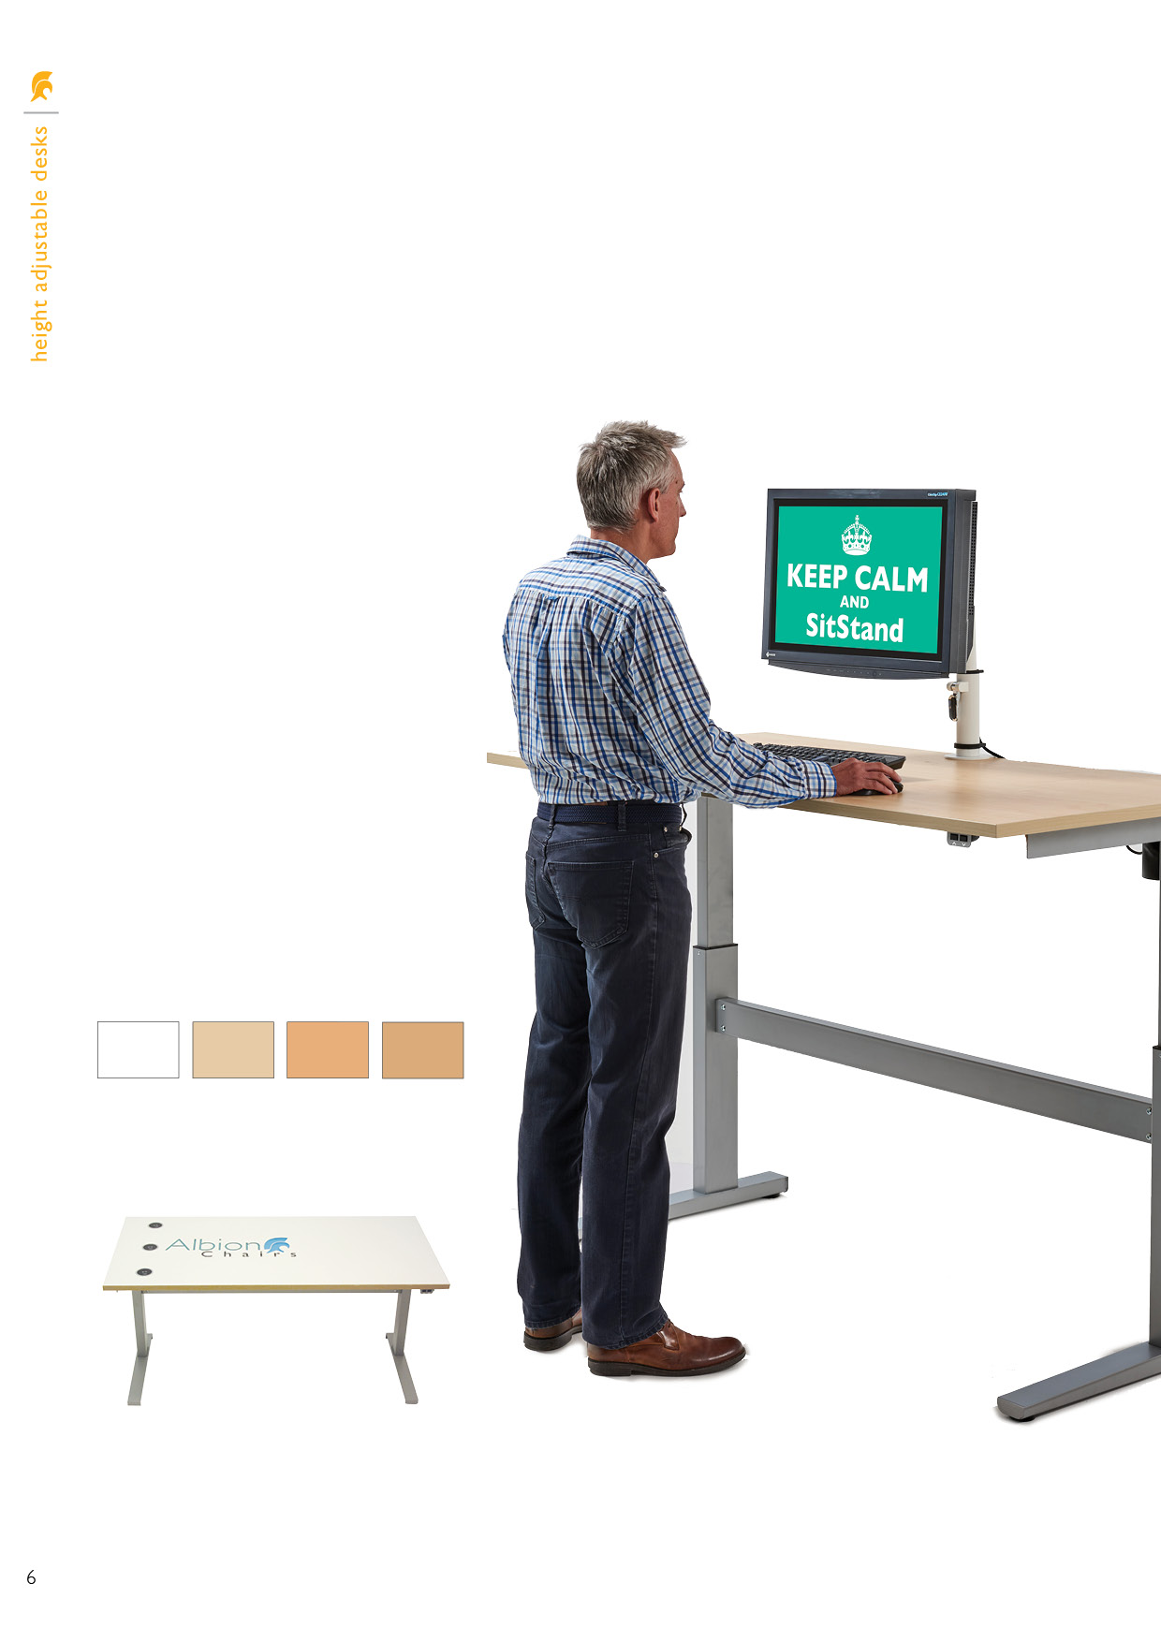

**Sitstand desk unassembled and no top**  
£560.00

**Sitstand desk assembled and no top**  
£600.00

**Sitstand desk complete with top**  
£700.00

**End user installation with delivery  
of bad back chair(s)**  
£140.00

**End user installation without   
delivery of bad back chair**  
£200.00

Made to order, bespoke tops as shown including the ability to fit aircharge ports is also available on request.

Light Oak

Beech

Maple

White

**Table top colours available**

## Desk pricing

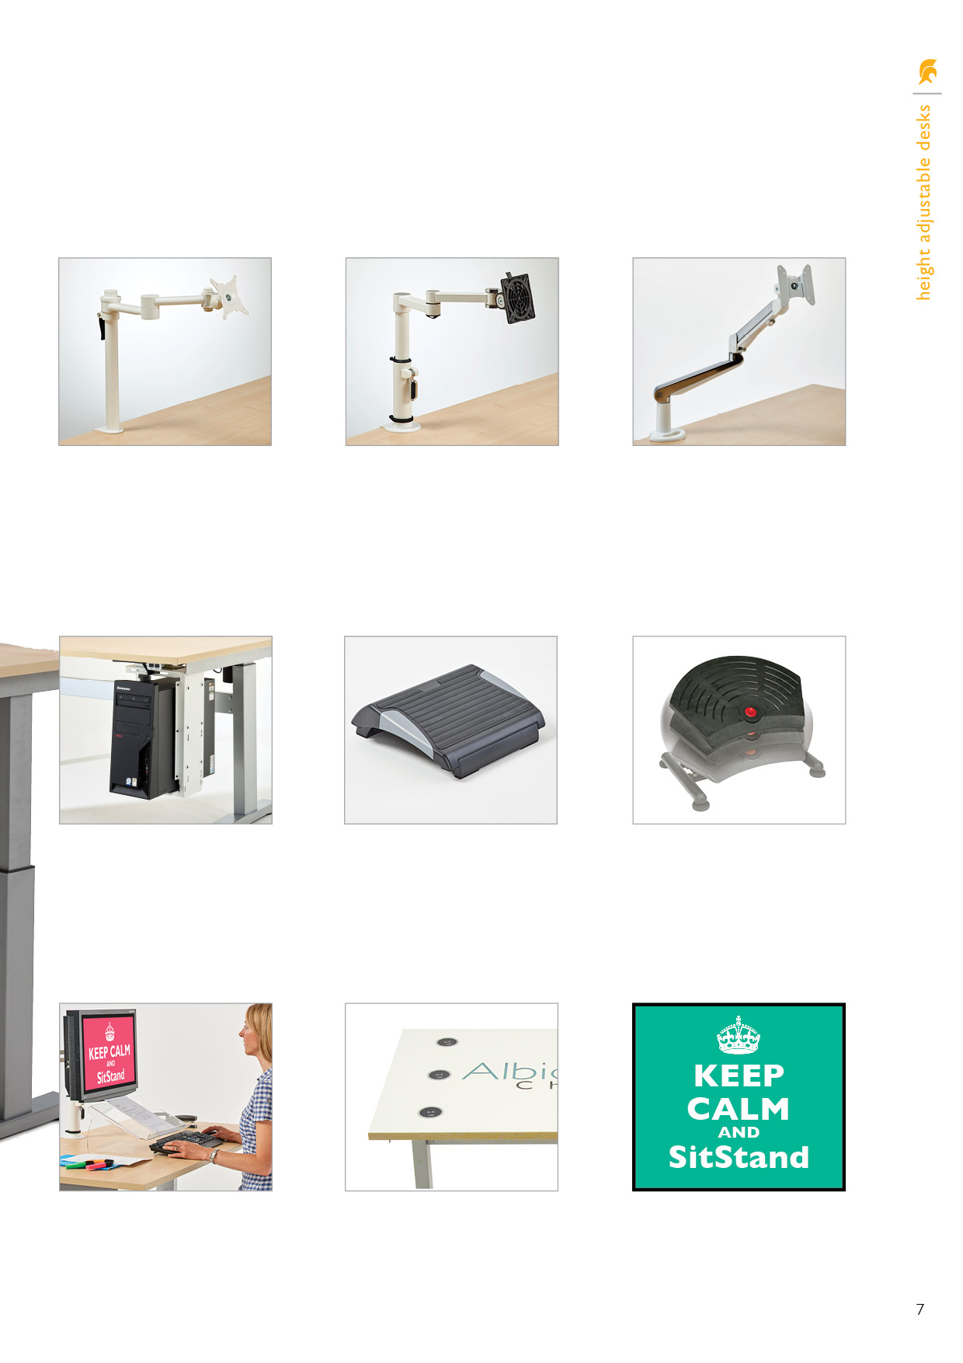

MA1 - entry level

£125.00

Shown in white, also available in silver and black.

MA2 - entry level

£160.00

MA3 - entry level

£280.00

Sliding/swivelling CPU holder

£120.00

Shown in white, also available in silver and black.

Footrest

£50.00

TS100 Footrest

£312.00

Desktop document holder

£80.00

Clear acrylic

Aircharge port(s)

£140.00

**Monitor arms**

## Accessories pricing

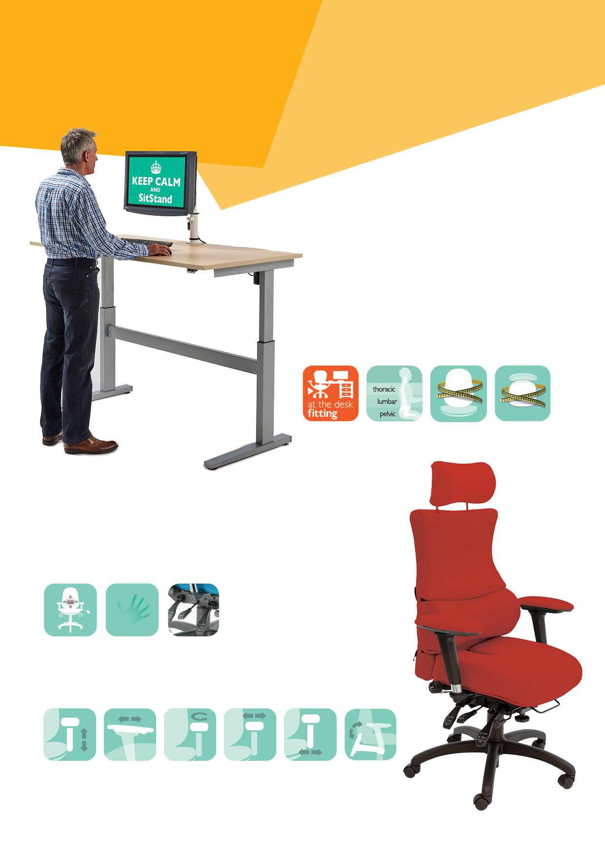

**Ergonomic Solutions**

* Whether your problem is in the coccyx, pelvic, lumbar, thoracic or cervical area, we offer the back shape, head/neckrest and pneumatic/mechanical lumbar/pump and memory foam upholstery to suit your personal support requirements.
* The most adjustable heavy duty mechanism available; our 6 way adjustable Spynamics mechanism has the greatest range of infinite lock of seat and back tilt on the market with: ratchet backrest height, seat slide (depth) and tilt tension adjustment.

For further information, please call our sales office on 01494 464656, or fax 01494 474760

e-mail: sales@albionchairs.com www.albionchairs.com

**SPYNAMICS** is synonymous with ergonomic and orthopaedic seating in the workplace. The result of a collaboration in 1999 between Albion Chairs and a leading osteopath, **SPYNAMICS** was developed for users with chronic bad backs. Since then, it has continued to evolve as practitioners and users have contributed to our knowledge pool.

With our dealers, we have extended our workstation assessment service to provide an at-your-desk evaluation. We can provide a made to order chair by taking your seated measurements. This includes looking at desk layout, monitor height, keyboard and mouse accessibility and footrest requirement. We also advise on the need for an electric sit/stand desk.

Made to

order seat

Made to

order back

Height

adjustable arm

Adjustable

swivel

Adjustable

slide

Foldaway

arm

Adjustable

armpad width

Adjustable

seat width

Spynamics

mechanism

Memory

foam

Pneumatic pump and

mechanical 2 way lumbar

* 2, 3, 4, 5, and 6 way adjustable multifunctional height adjustable arms achieve the arm support you need no matter the desk you work at.

## Workstation assessments

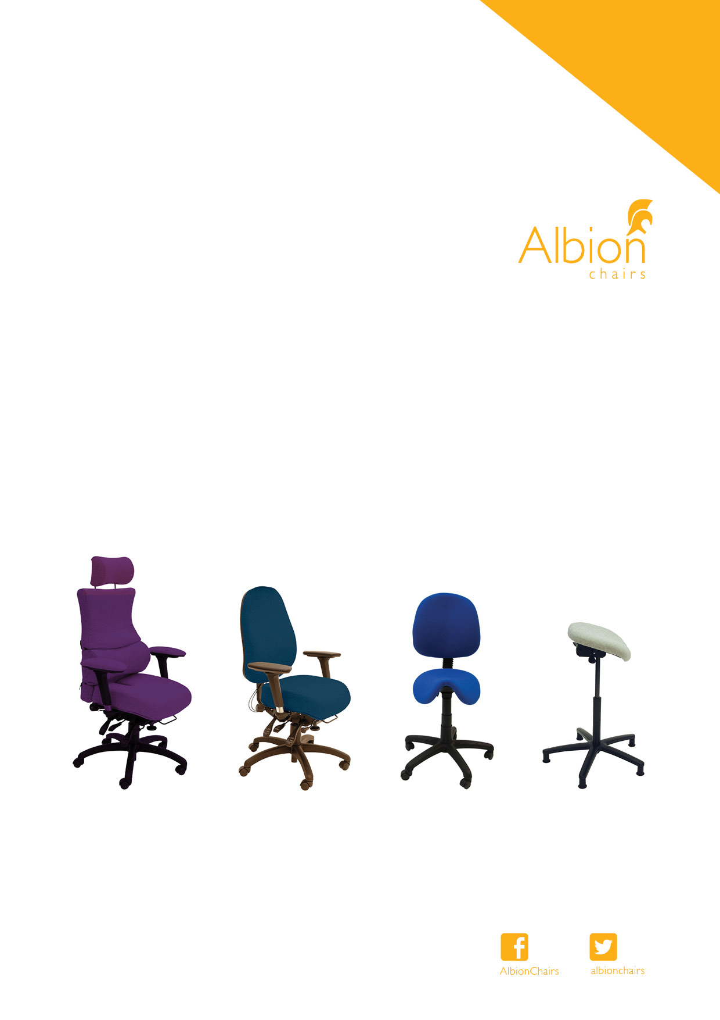

**Albion Chairs Limited,**

Albion House,

Lane End Road, Sands,

High Wycombe

HP12 4HG

Tel **01494 464656**

Fax **01494 474760**

E-mail **sales@albionchairs.com**

**www.albionchairs.com**

E. & O. E. excepted