**Put your details here**

Height adjustable   
SitStand solutions

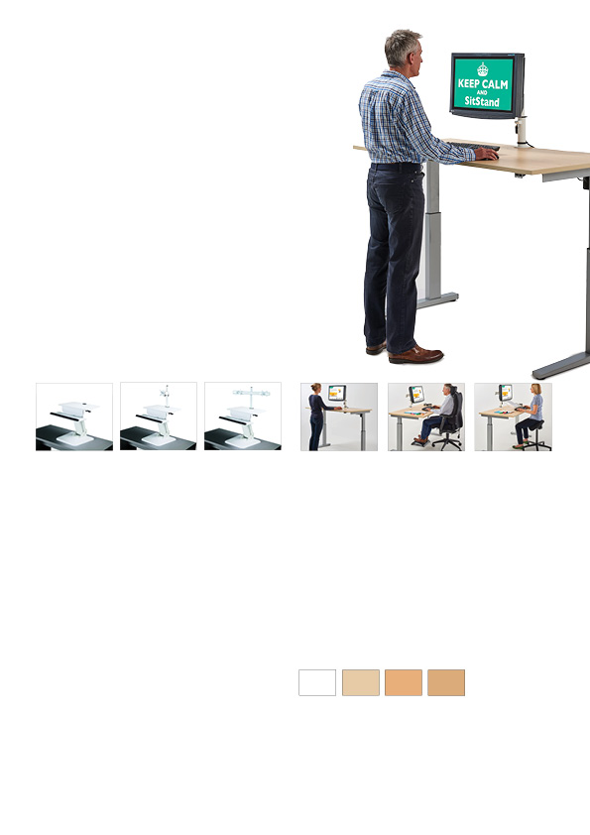

Light Oak

Beech

Maple

White

For our SitStand desks, we stock 4 colours: white, maple, beech and light oak in 4 sizes: 1200, 1400, 1600 and 1800 by a depth of 800mm. It is possible to supply other colours, with portholes and with reduced depth of 700mm if required. There is a 3-4 week leadtime for this.

Standard leadtime is 2 weeks.

We can supply our SitStand desks in 3 ways:

• without top/unassembled

• without top/assembled

• assembled with top

You can therefore provide your own top or reuse the in situ desktop.

Our single motor electric SitStand desk has a height range of 680-1180mm without top, a variance of 500mm. Our standard tops are 25mm thick making the range 705-1205mm. The width can be adjusted from 1160-1700mm allowing for a range of top widths. We stock 3 colours of frame: silver, black and white.

The desk mounted SitStand unit can be supplied without a monitor arm to allow for laptop/remote keyboard set up, or can be supplied with a single or double monitor arm connected to your hard drive.

The desk mounted SitStand unit is able to vary the desk height by 423mm which means if you allow for an average desk height of 700mm, the desk mounted SitStand unit will give you a variance of 710-1133mm.

Our desk mounted SitStand unit is available in white and can be placed on any solid surface to turn almost any area into a ‘SitStandable’ work area. This is especially useful if you work from home or in a tight space.

Standard leadtime is a week.

SitStand height adjustable desks allow office and home workers to enjoy the ergonomic and health benefits of both sitting and standing while   
they work.

Using a SitStand desk promotes good blood circulation, prevents problems associated with prolonged sitting and can result in increased alertness and activity levels.

It also helps fight fatigue by making it easier to focus on work tasks, improving mood and productivity levels for longer.

There are two options available to achieve this
nowadays; a desk mounted sitstand unit or a
sitstand desk.

**SitStand desks**

**Desk mounted SitStand unit**

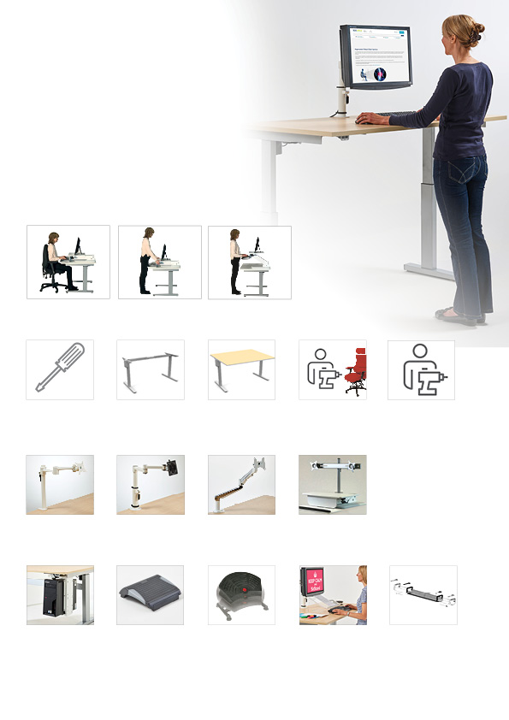

**Put your details here**

Desktop document holder
£

Clear acrylic

MA1 - entry level £

Shown in white, also available in silver and black.

MA2 - mid level £

MA3 - top level £

MA4V - double arm only available in silver £

Sliding/swivelling CPU holder
£

Shown in white, also available in silver and black.

Footrest £

TS100 Footrest £

Black telescopic cable tray
£

Sitstand desk complete with top £

End user installation with delivery of bad back chair(s)
£

End user installation without delivery of bad back chair(s)
£

Sitstand desk assembled and no top £

Sitstand desk unassembled and no top £

PRICING

Desks

Our electric SitStand desks are offered alongside workstation accessories such as monitor arms, a sliding retractable CPU holder, a document holder and footrests.

We also provide a telescopic cable tray. All available on a 2 week leadtime, our SitStand desk frame comes with a 5 year guarantee.

Our SitStand desk and accessories can be delivered and installed direct to the end user. Pricing is dependant on whether we have a bad back chair to deliver at the same time or not.

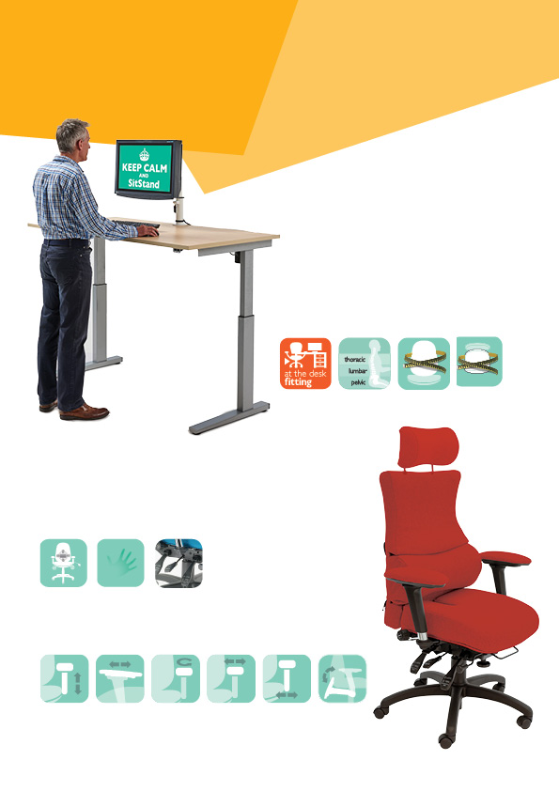

**Put your details here**

**Ergonomic Solutions**

* Whether your problem is in the coccyx, pelvic, lumbar, thoracic or cervical area, we offer the back shape, head/neckrest and pneumatic/mechanical lumbar/pump and memory foam upholstery to suit your personal support requirements.
* The most adjustable heavy duty mechanism available; our 6 way adjustable Spynamics mechanism has the greatest range of infinite lock of seat and back tilt on the market with: ratchet backrest height, seat slide (depth) and tilt tension adjustment.

**SPYNAMICS** is synonymous with ergonomic and orthopaedic seating in the workplace. The result of a collaboration in 1999 between Albion Chairs and a leading osteopath, **SPYNAMICS** was developed for users with chronic bad backs. Since then, it has continued to evolve as practitioners and users have contributed to our knowledge pool.

With our dealers, we have extended our workstation assessment service to provide an at-your-desk evaluation. We can provide a made to order chair by taking your seated measurements. This includes looking at desk layout, monitor height, keyboard and mouse accessibility and footrest requirement. We also advise on the need for an electric sit/stand desk.

Made to

order seat

Made to

order back

Height

adjustable arm

Adjustable

swivel

Adjustable

slide

Foldaway

arm

Adjustable

armpad width

Adjustable

seat width

Spynamics

mechanism

Memory

foam

Pneumatic pump and

mechanical 2 way lumbar

* 2, 3, 4, 5, and 6 way adjustable multifunctional height adjustable arms achieve the arm support you need no matter the desk you work at.

## Workstation assessments