­­­

**R4**

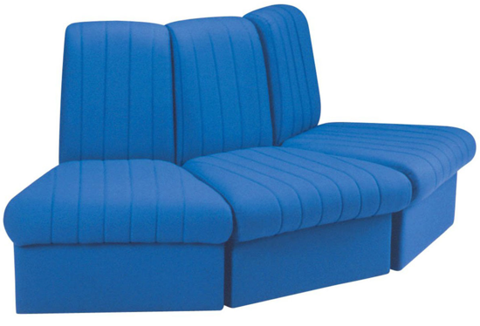

255

255

255

670

670

670

700

790

**AR3**

430

535

360

790

600

700

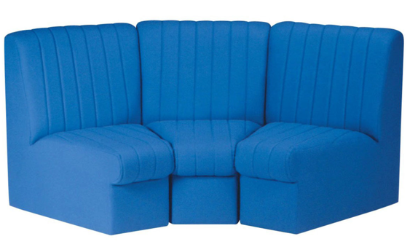

**ARCH**

700

790

590

590

590

255

255

255

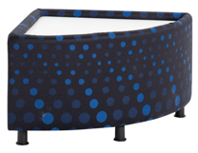

**R8**

360

650

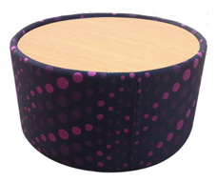

**R7**

360

650

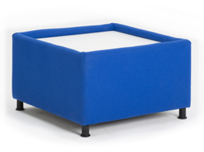

360

650

650

**R6**

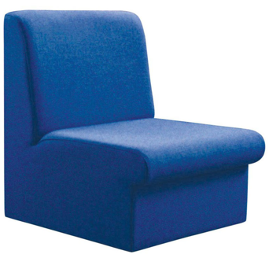

**R1**

430

535

360

790

600

700

Modular Seating

All dimensions in mm

**Reflex R/AR3**

t

For further information, please call our sales office on **01494 464656**, or fax **01494 474760**

e-mail: sales@albionchairs.com www.albionchairs.com