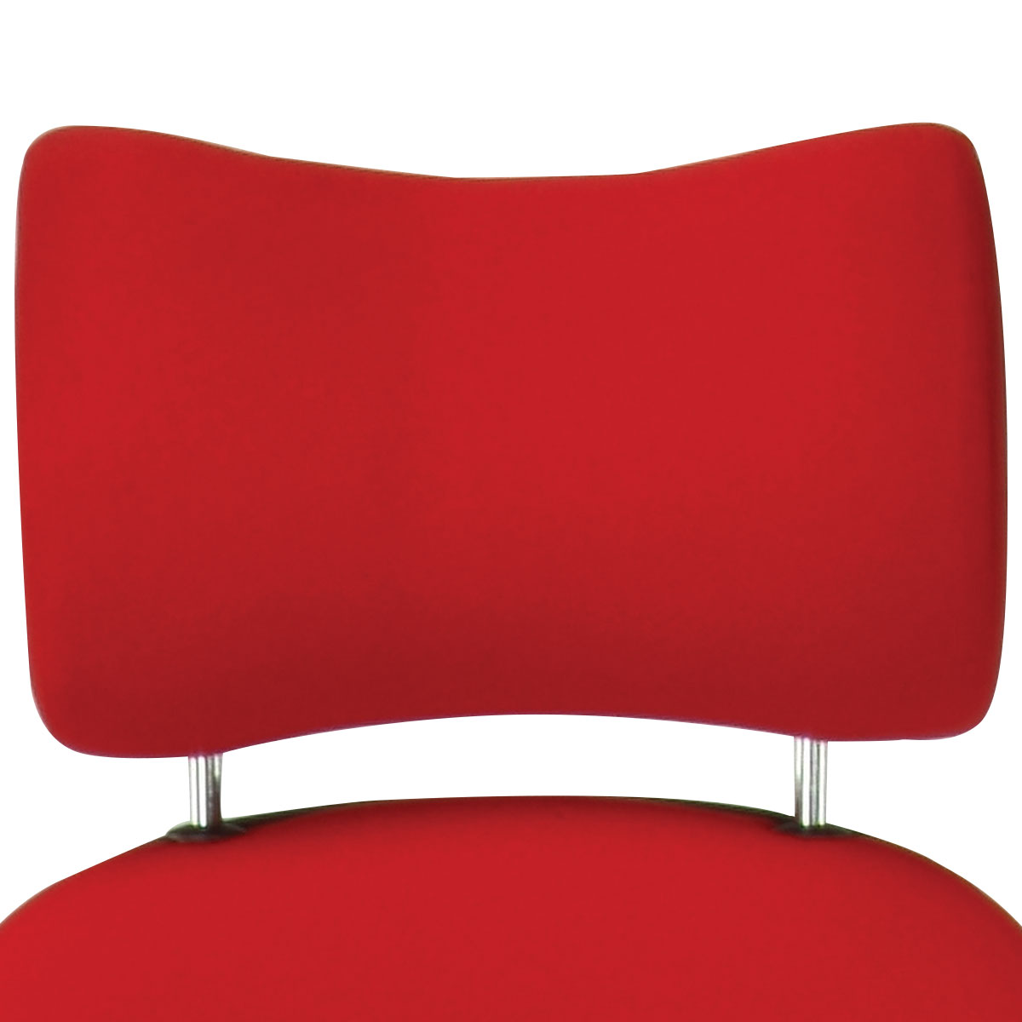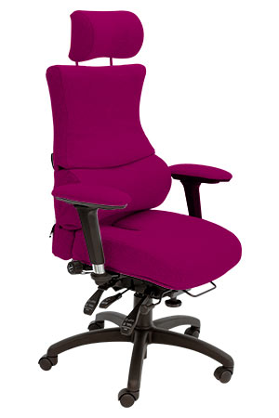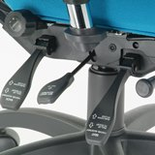

According to the Health & Safety Executive, businesses lose some 4.9 million working days due to work-related back pain every year with each affected employee taking an average of 19 days off work.

The charity, BackCare, estimates that the overall cost of back pain to the NHS, businesses and the economy is £5 billion a year.

Launched in 1999, Albion Chairs’ Spynamics range of office chairs incorporates a unique and innovative design to provide a complete solution to back problems in the workplace.

Comprehensive Ergonomic Back Pain

Solution in the Workplace

**Spynamics**

Developed in conjunction with an industry leading osteopath, Stephen Green, the Spynamics (Spinal-Dynamics) range has fourteen models to suit users of differing shapes and sizes. Whether it’s for a chronic or a mild back pain sufferer – each model is designed to ensure that each spine receives optimum support.

*“The pelvis is the foundation of the spine and if positioned correctly will help the rest of the spine align correctly.*

*The Spynamics range boasts the use of the most up to date materials such as memory foam, made-to-measure seat sizes, a coccyx relief cut out, head and neck rests, multifunctional adjustable arms, and the heaviest duty ergonomic seat mechanism available”.*

**Stephen Green**

Former Lecturer at the British School of Osteopathy

SD3 High Back

Model features include:

* **Chronic Back Pain** – SD1 to SD8 models provide our unique triangulation of support cradling the pelvis
* **Mild Back Pain** – SD9 to SD14 offer memory foam on the seat to help relieve the pressure from sitting for extended periods

For more information and prices, please contact **Phil Pask** on **07803 120155**