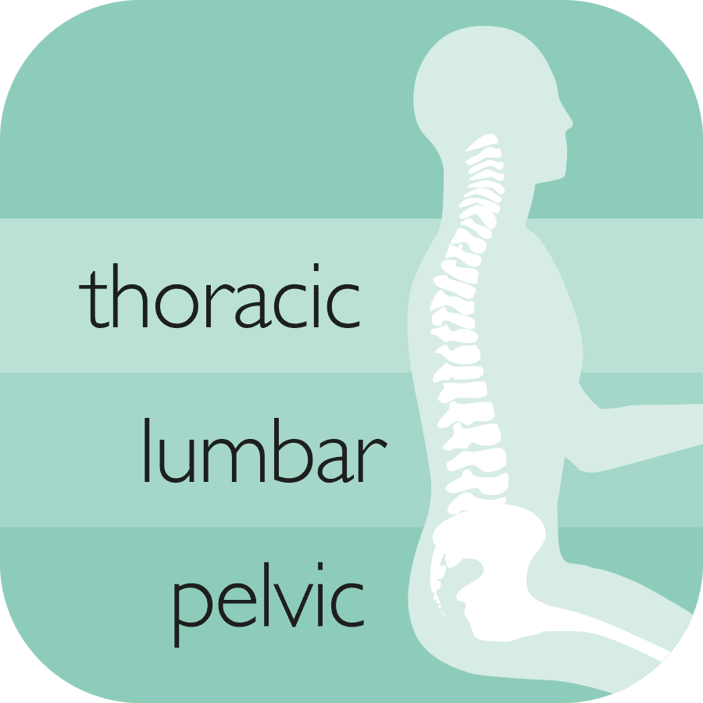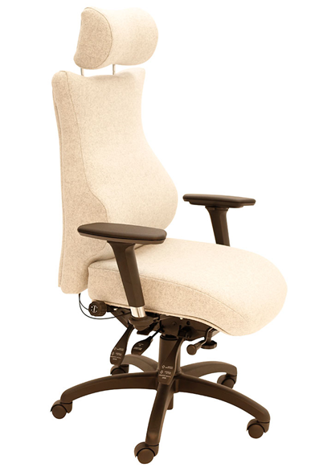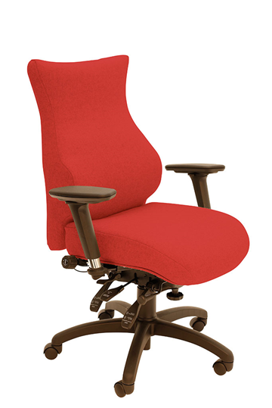

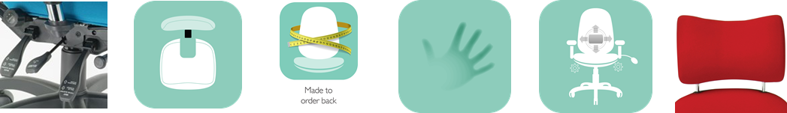

For more information and prices, please contact **Phil Pask** on **07803 120155**

Other ergonomic features include:

* **6-way adjustable forward tilting mechanism:** adjustable for seat tilt, depth, height, tension (weight) control, backrest height (ratchet) and tilt
* **6 seats to complement 2 back configurations** including height and tilt adjustable headrest for custom built comfort
* **5-way adjustable PU arms;** adjustable for: height, depth (forward and back), width and (locking) swivel

1. The **triangulation of support** provided by the **integrally upholstered pelvic support**, the 3 way adjustable lumbar and the Thoracic pump
2. The optional **coccyx relief cut out**
3. The use of **memory foam**

SD5 High Back with Headrest

**SD4 SD5**

Chronic Back Pain Seating

Each chair is designed in a **modular fashion** to ensure each key area of the spine receives **optimal support**. The unique features are:

SD4 High Back Model