Not everyone works at a 720mm static height desk, a lot of people work at different workstations, benches, counters etc. They don’t always work at computers typing on keyboards, sometimes they are working on an assembly line, in labs with microscopes, with money, with people’s eyes, teeth etc and more and more people are sitting at (electric) height adjustable desks. The saddle seat enables the hip joint of the user to be kept at an optimal angle of 135 degrees which encourages the spine “S” shape posture and puts much less stress on the vertebrae and discs in the back.

The stools and chairs shown can provide an answer to these requirements (as well as) leg rests and can be sold as seen or with different spindles, castors, glides, footrings etc to ensure the finished article best fits the needs of the user, their job and their environment (flooring etc).

**Stools & saddles**

t

SitStand solutions

TS4

TS3DBL

TS1

TS2

For further information, please call our sales office on **01494 464656**, or fax **01494 474760**

e-mail: sales@albionchairs.com www.albionchairs.com

135 degrees represents the optimum angle for good spine posture.

SitStand solutions

**Stools & saddles**

t

TS3



**Stools & saddles**

t

SitStand solutions

TS5

TS6

TS100

TS7

135 degrees represents the optimum angle for good spine posture.

For further information, please call our sales office on **01494 464656**, or fax **01494 474760**

e-mail: sales@albionchairs.com www.albionchairs.com

For further information, please call our sales office on **01494 464656**, or fax **01494 474760**

e-mail: sales@albionchairs.com www.albionchairs.com

TS9

135 degrees represents the optimum angle for good spine posture.

TS10

TS12

TS2000

SitStand solutions

**Stools & saddles**

t

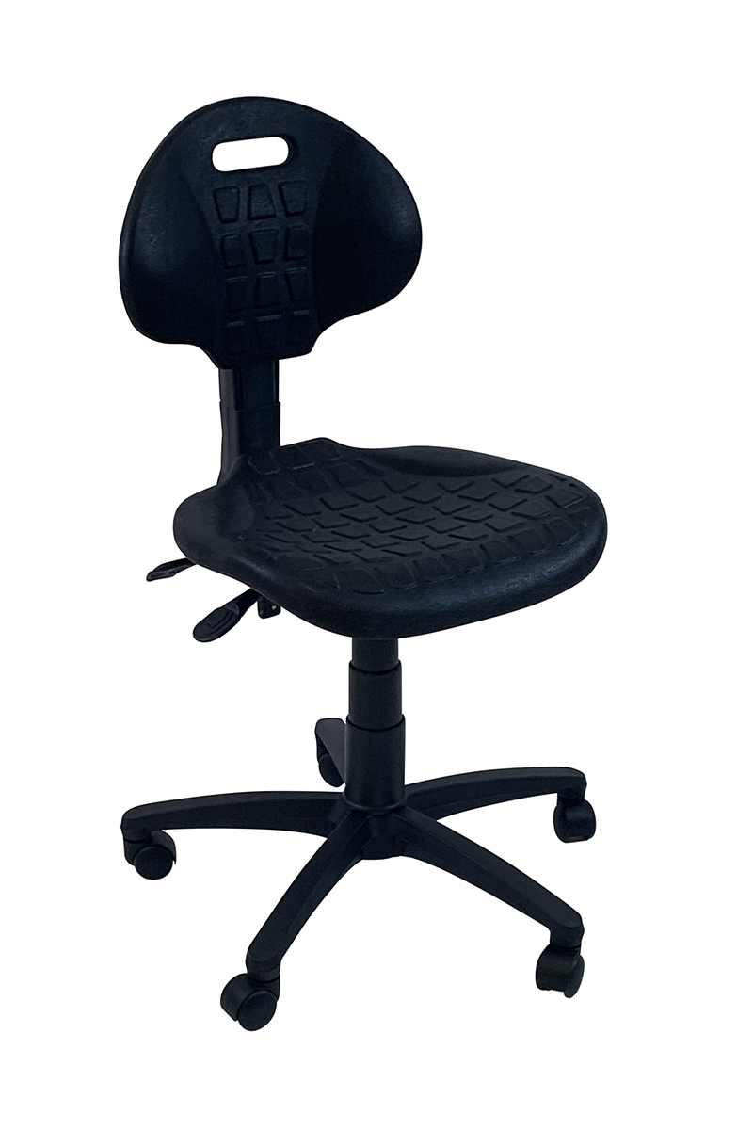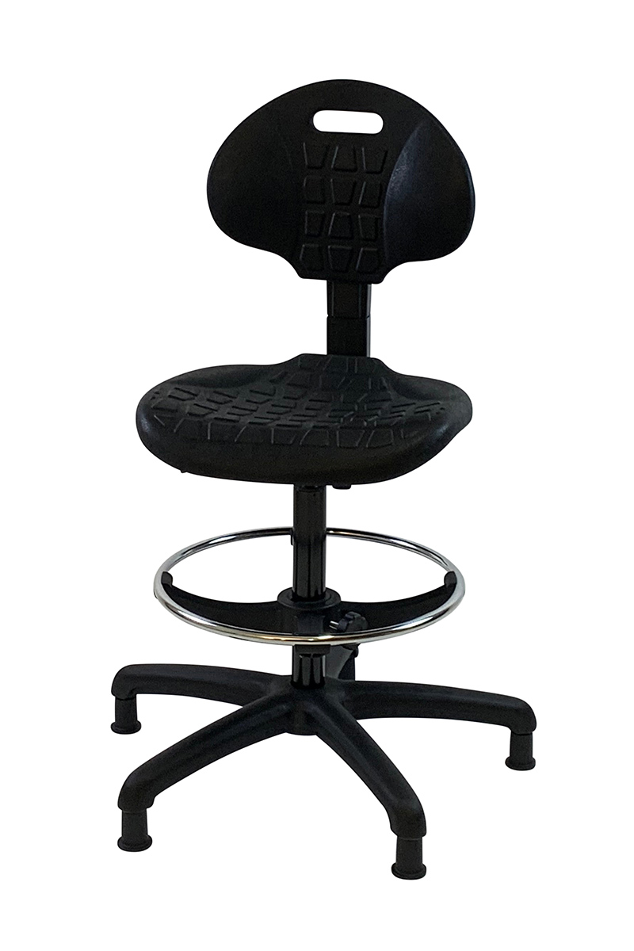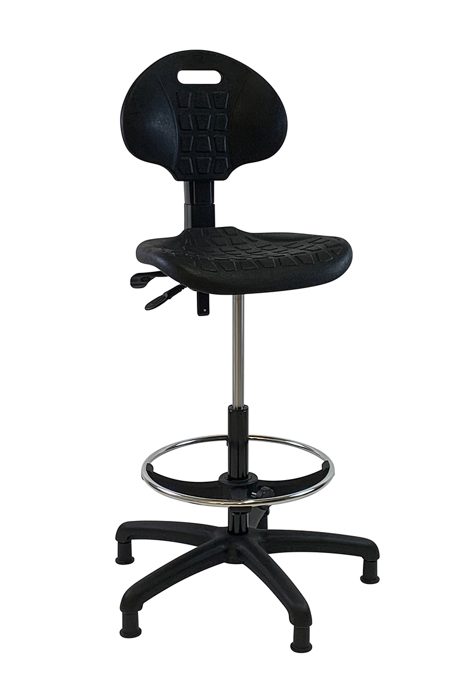

**PU (polyurethane) Industrial seating**

PU1 BM with castors

PU1 D14 FRX GL

PU1 D14 FRX GL

**Stools & saddles**

t

SitStand solutions

For further information, please call our sales office on **01494 464656**, or fax **01494 474760**

e-mail: sales@albionchairs.com www.albionchairs.com