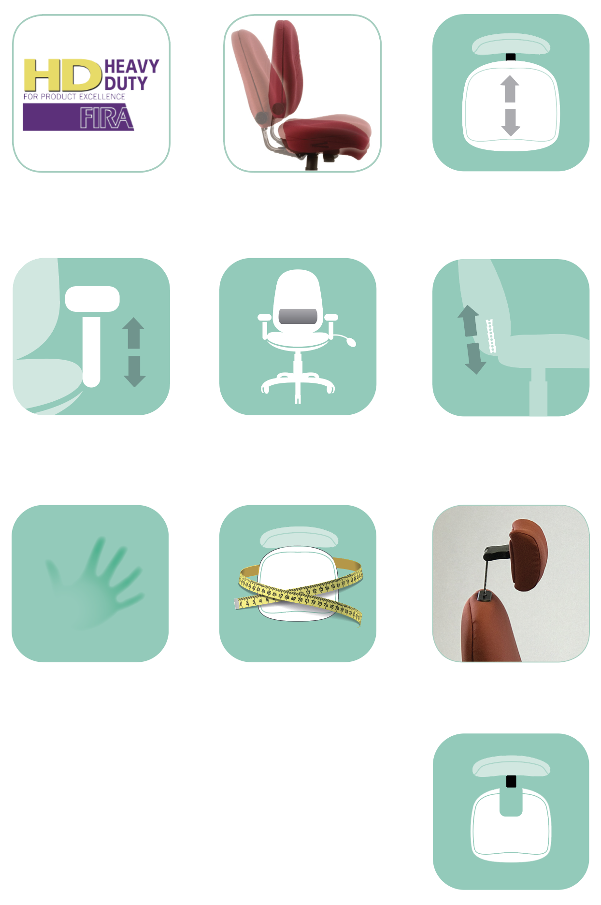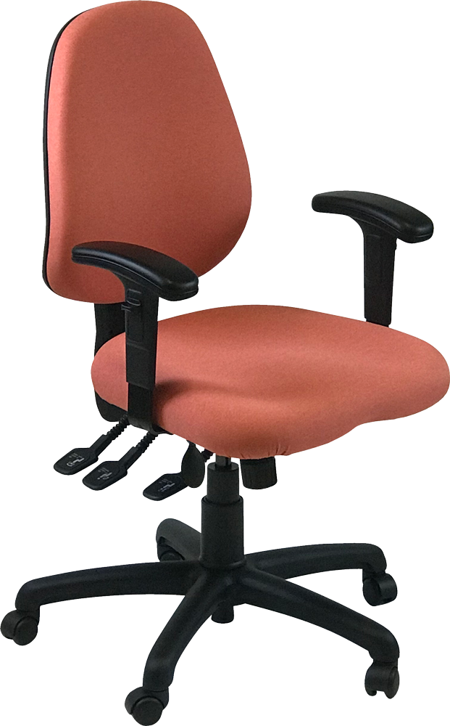

For more information and prices, please contact

**Phil Pask** on **07803 120155**

Back: 500 x 440mm (HxW) Seat: 470 x 500mm (DxW)

* Headrest
* Polished chrome/silver base
* At your desk fitting/assessment
* Draughtsman/counter height spindles footrings/alternative castors/glides
* 24/7 – 3-shift pattern guaranteeable   
  (max 2 years)
* Other fabrics

Optional extras:

* Alternative multifunctional   
  and/or foldaway arms
* Additional lumbar or thoracic support
* Made to measure seat size
* Memory foam seat or back layer
* Coccyx cut out
* Seat air bag

Fira 24/7

Independent seat and back tilt

Seat slide mechanism

Height adjustable arm

LP Lumbar support pump

Ratchet backstem

Memory foam

Made to   
measure seat

Coccyx cut out

Headrest

**STANDARD**

**Uni2A Bundle**

Large Operator Back Model

Pre-loaded Large Operator Back Multi-task Chair

Standard features:

* Ergonomically designed back
* Additional back lumbar support (pump)
* 6-way adjustable mechanism- seat tilt, seat tilt tension, seat depth (slide), seat height (gas), back rest tilt and backrest height (ratchet)
* Height adjustable arms
* Weight limit up to 150kgs, 5-year guarantee
* Priced in Camira Phoenix range

Highly adjustable task chair for **maximum functionality, minimum fuss** and unbeatable value for money

**Uni2**A