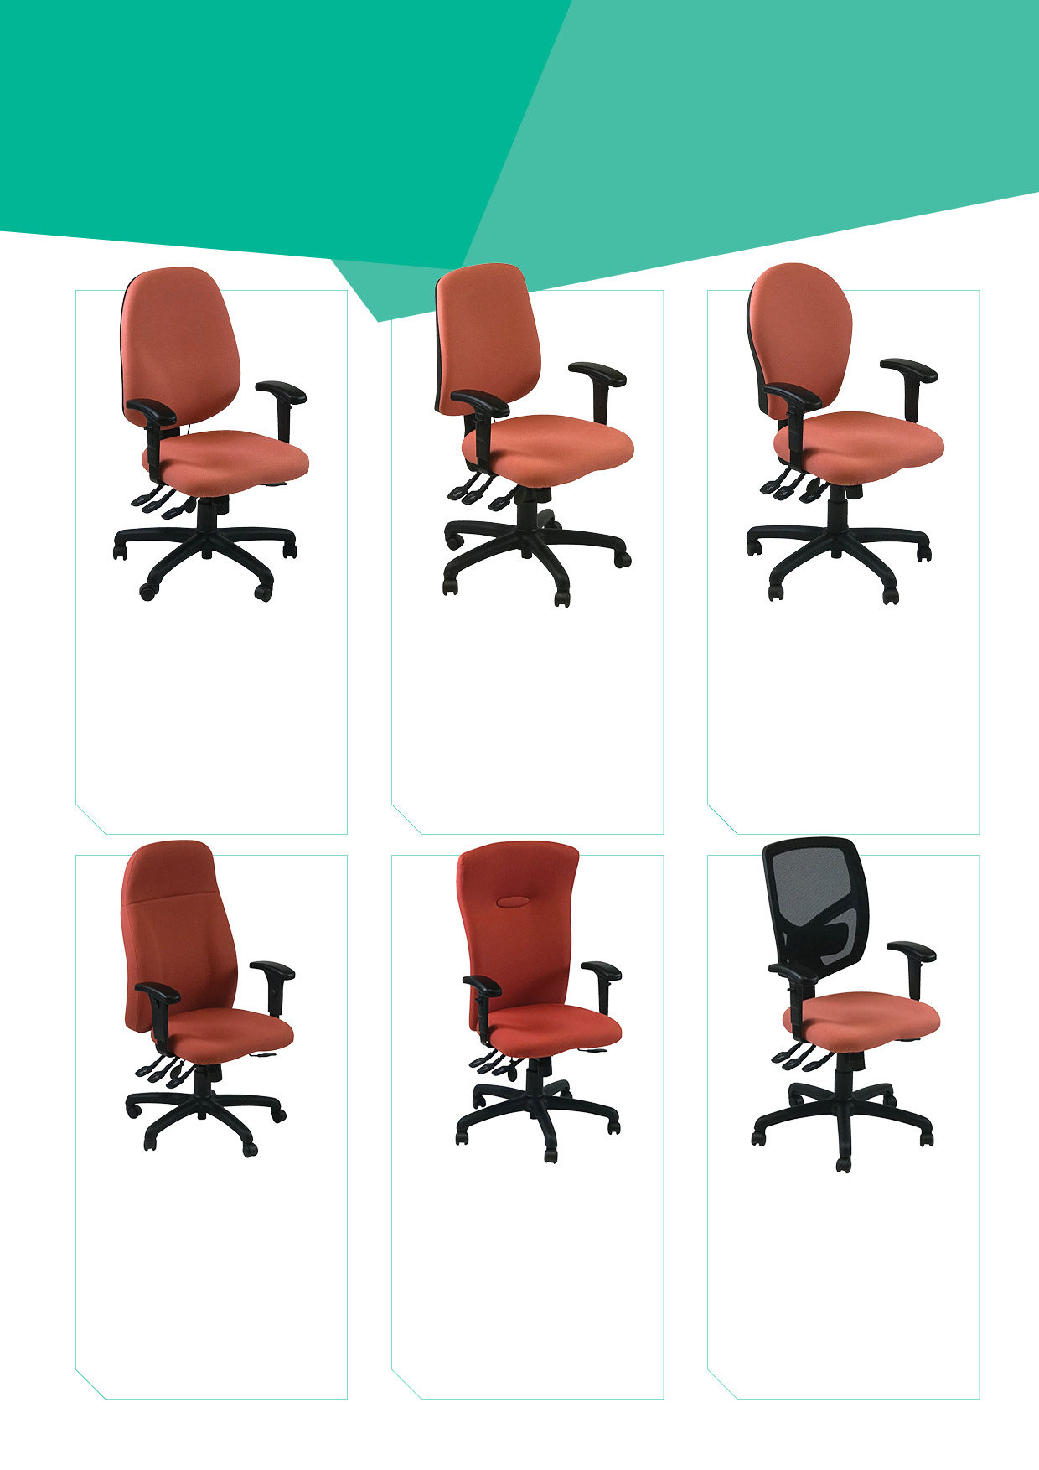

Uni75A BUNDLE

£438.00

**Weight guarantee:** 23.5 stone

**Features:** Adjustable pump lumbar, Ratchet backrest height, Back & seat tilt, Seat slide, Adjustable arms

**Dims:** Back 780(H) x 550mm(W)

Seat 470(D) x 500mm(W)

FULLY ADJUSTABLE EXECUTIVE HIGH BACK CHAIR

Uni85A BUNDLE

£438.00

**Weight guarantee:** 23.5 stone

**Features:** Adjustable pump lumbar, Ratchet backrest height, Back & seat tilt, Seat slide, Adjustable arms

**Dims:** Back 680(H) x 480mm(W)

Seat 470(D) x 500mm(W)

FULLY ADJUSTABLE EXECUTIVE
HIGH BACK CHAIR

Uni125A BUNDLE

£320.00

**Weight guarantee:** 23.5 stone

**Features:** Adjustable pump lumbar, Ratchet backrest height, Back & seat tilt, Seat slide, Adjustable arms

**Dims:** Back 580(H) x 490mm(W)

Seat 470(D) x 500mm(W)

FULLY ADJUSTABLE MESH TASK CHAIR

Uni105A BUNDLE

£288.00

**Weight guarantee:** 23.5 stone

**Features:** Adjustable pump lumbar, Ratchet backrest height, Back & seat tilt, Seat slide, Adjustable arms

**Dims:** Back 530(H) x 460mm(W)

Seat 470(D) x 500mm(W)

FULLY ADJUSTABLE TASK CHAIR

Uni35A BUNDLE

£288.00

**Weight guarantee:** 23.5 stone

**Features:** Adjustable pump lumbar, Ratchet backrest height, Back & seat tilt, Seat slide, Adjustable arms

**Dims:** Back 500(H) x 460mm(W)

Seat 470(D) x 500mm(W)

FULLY ADJUSTABLE TASK CHAIR

Uni45A BUNDLE

£288.00

**Weight guarantee:** 23.5 stone

**Features:** Adjustable pump lumbar, Ratchet backrest height, Back & seat tilt, Seat slide, Adjustable arms

**Dims:** Back 580(H) x 490mm(W)

Seat 470(D) x 500mm(W)

FULLY ADJUSTABLE TASK CHAIR

For more information and prices, please contact **Phil Pask** on **07803 120155**

**UniBundle**Overview

2019