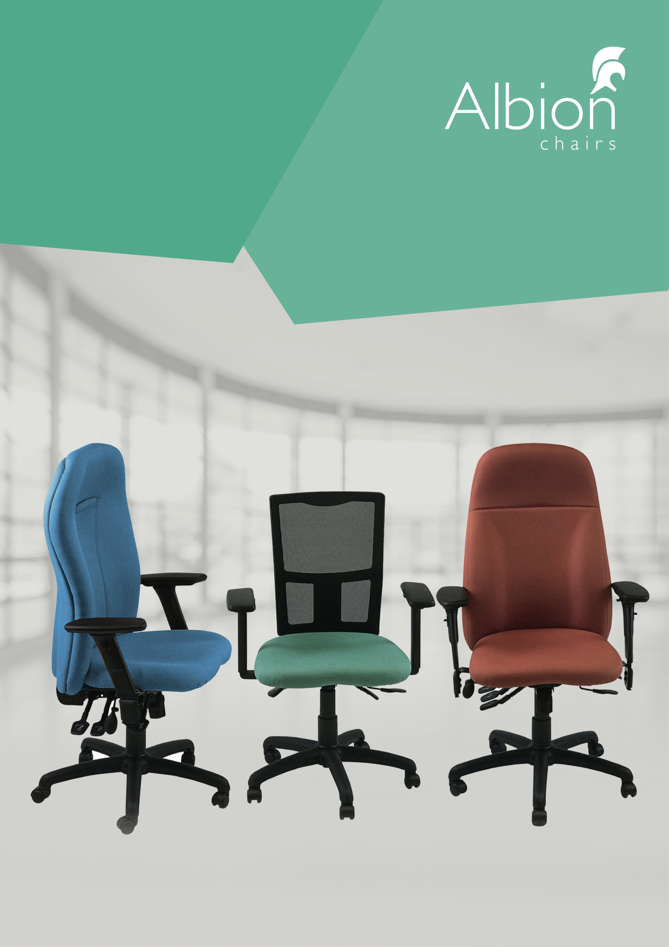

Uni Bundles
RETAILS
MAY 2020

bundles
Uni bundles epitomise workplace ergonomics made simple. All models allow for adjustment of: Back and seat tilt, backrest height, seat depth, arm height and lumbar support. A simpler code and a net price = fuss free specification.

The Uni 0A, 1A and 11A offer a max weight limit of 120kgs (19 stones) and can be offered in 24/7 environments for a maximum of 18 months.

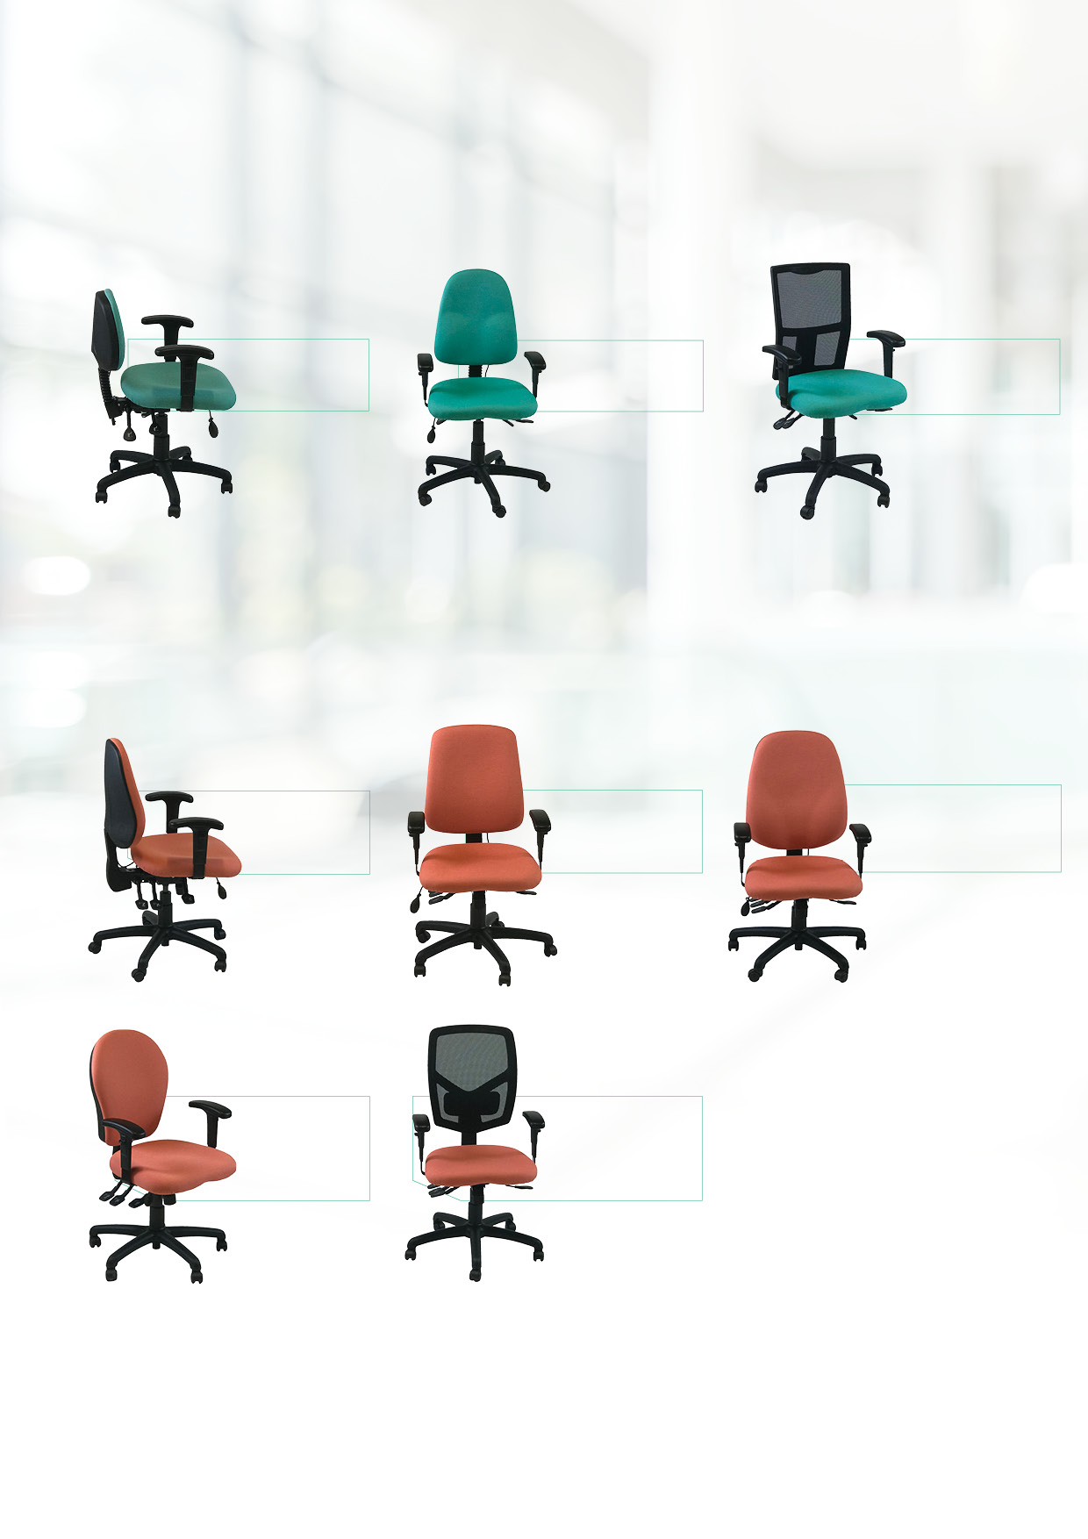
The Uni 2A, 3A, 4A, 10A and 12A offer a max weight limit of 150kgs (23.5 stones) and can be offered in 24/7 environments for a maximum of 2 years.

Uni4A

Uni2A
COL 1
£302.50
COL 1
£302.50
COL 1
£302.50

Uni10A

Uni3A

Uni12A
COL 1
£302.50
COL 1
£337.50
COL 1
£255.00
COL 1
£255.00
COL 1
£277.50

Uni0A

Uni11A

Uni1A
UNI | Metrage | COM | COL2 | COL3 | COL4 | COL5 | COL6 | COL7 | COL8
UNI0 / 1 / 2 / 3 / 4 / 10 / 11 / 12 | 0.8 | -£10.00 | £12.33 | £24.53 | £41.11 | £59.68 | £87.53 | £115.37 | £152.50
UNI 5 / 6 / 7 / 8 | 1.9 | -£20.00 | £24.53 | £54.37 | £87.53 | £131.28 | £185.66 | £249.31 | £275.83
UNI 9 | 2.8 | -£34.00 | £37.54 | £85.82 | £134.12 | £198.47 | £284.28 | £375.48 | £418.40
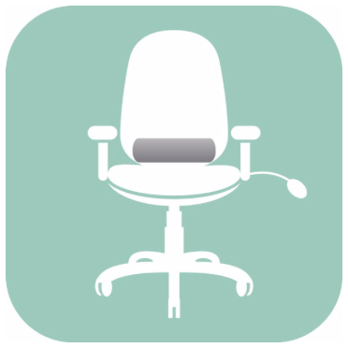
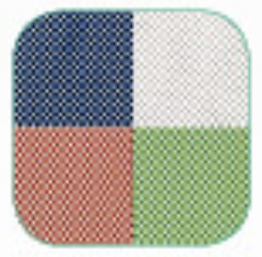
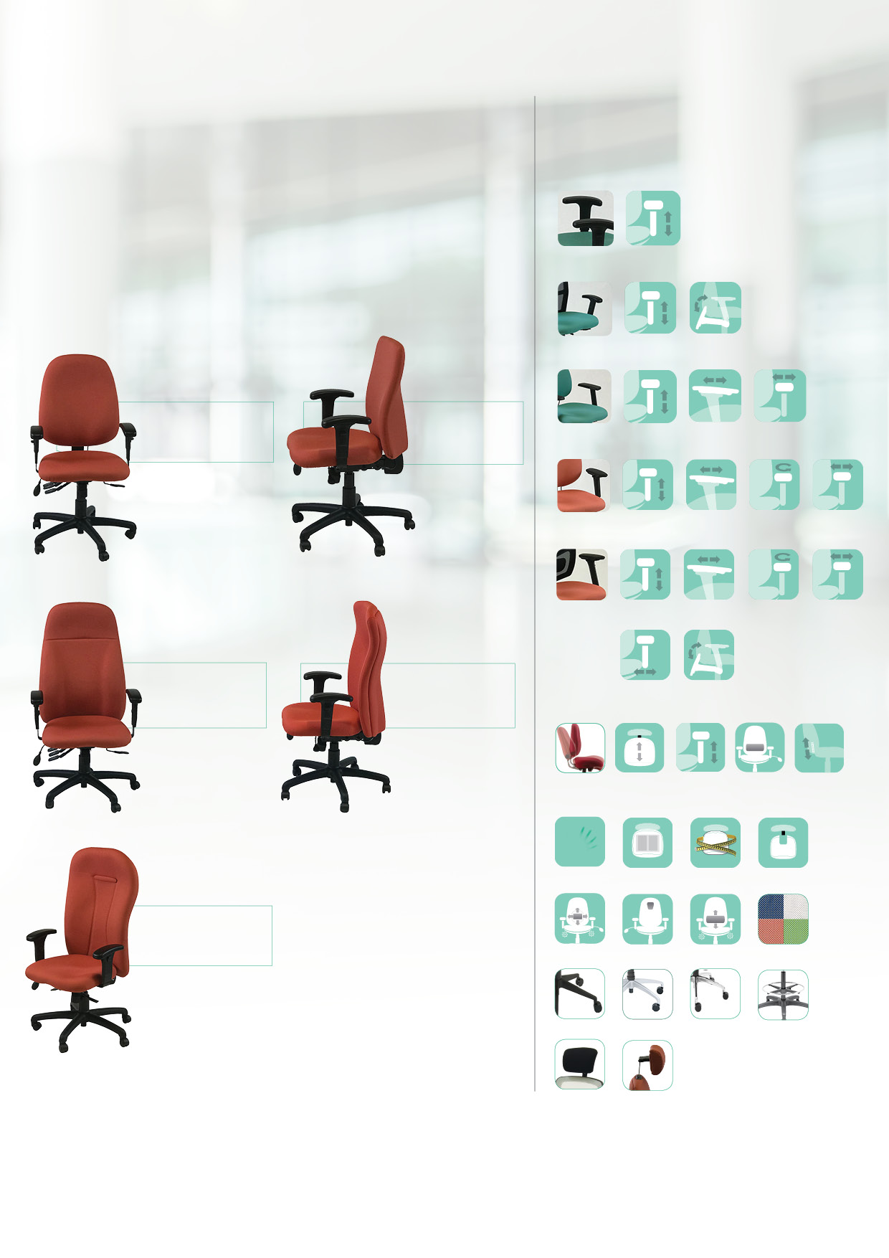
HR2
Headrest £100.00
Mesh
Uni 11/12 only £21.75

Height adjustable arm
Ratchet
backstem
TP
Thoracic pump £35.00
L2 LP
Lumbar £56.25
SP
Sacral pump £35.00

L2
2-way Adj. Lumbar £35.00
BB
£16.50
VL
£35.00
XL
£35.00
D/MAN 12/142FRX
£80.00
MF
Memory Foam Back £56.25
Memory Foam Seat £56.25
MF2
Airbag Seat
£56.25
MTO
Made to measure £56.25
CC
Coccyx Cutout £50.00
HR12
Headrest £46.00

Included

Other options and personalisations

Independent seat and back tilt
Sliding seat
Height
adjustable arm
Additional lumbar support

Other options and personalisations

These heavy duty pre-loaded bundles have fully upholstered plywood backs to add an executive finish to the workplace. These too have the fully ergonomic configuration of seat and back tilt, backrest height (ratchet), seat depth adjustment, pump lumbar and height adjustable arms. The Uni 5A, 6A, 7A, 8A and 9A offer a max weight limit of 150kgs (23.5 stones) and can be offered in 24/7 environments for a maximum of 2 years.
Adjustable seat width
Foldaway
arm
Adjustable armpad width
Adjustable armpad width
Height adjustable arm
Adjustable
slide
Adjustable
swivel
Adjustable
slide
Adjustable
swivel
Adjustable armpad width
Foldaway
arm
Foldaway
arm
Height adjustable arm
Height adjustable arm
Height adjustable arm
A3B Arm Functions +£56.25

A4X Arm Functions +£56.25

FA6 Arm Functions +£56.25

FA Arm Functions +£13.88

A Arm as shown in images

If you do want to personalise a little bit more, you can choose from the arms and other options below to further enhance the functionality or appearance.
COL 1
£462.50
COL 1
£462.50
COL 1
£412.50
COL 1
£412.50

Uni5A

Uni6A

Uni9A
COL 1
£515.00

Uni7A

Uni8A

Backs
You can choose from 13 backs with the dimensions shown. Standard support comes with pump lumbar. All backs allow for backrest height adjustment.
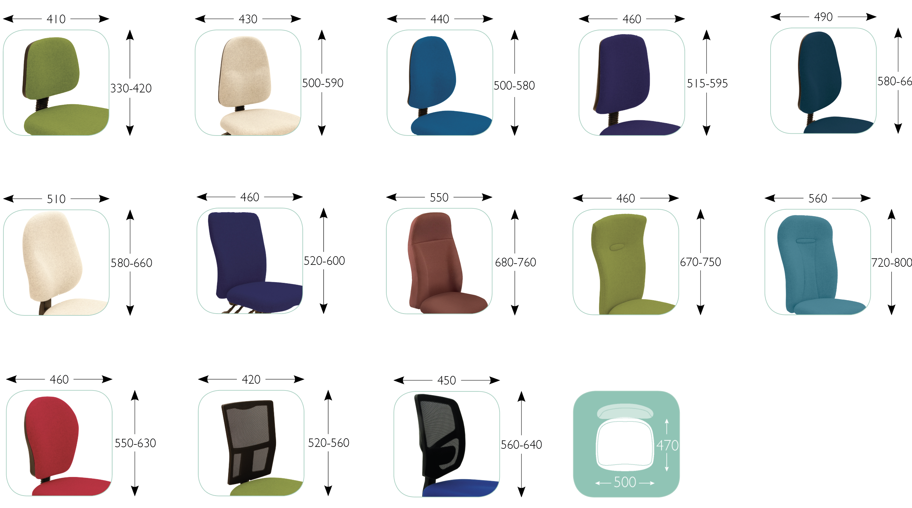
C
C seat
470D x 500W mm
Uni 12 back
Uni 10 back
Uni 11 back
Uni 9 back
Uni 8 back
Uni 7 back
Uni 6 back
Uni 5 back
Uni 3 back
Uni 2 back
Uni 4 back
Uni 1 back
Uni 0 back

Fabric selector
Column | Camira
1 | Citadel (reduced colours), ERA, Phoenix, Rivet
2 | Advantage, Aspect, Canopy, Chateau, Gravity (reduced colours), Main Line Plus, Manhattan, Manila, Patina, Sprint (reduced colours), Urban, Vita, X2, Xtreme +
3 | Honeycomb, Main Line Flax
4 | 24/7 Flax, Aquarius, Blazer, Halcyon (Aspen, Cedar and blossom), Hemp, Hi Tech(anti-static), Intervene (Plain and Texture), Landscape (Balance and Contact), OCEANIC, Oxygen (Min Order Qty 80m per colour), Synergy

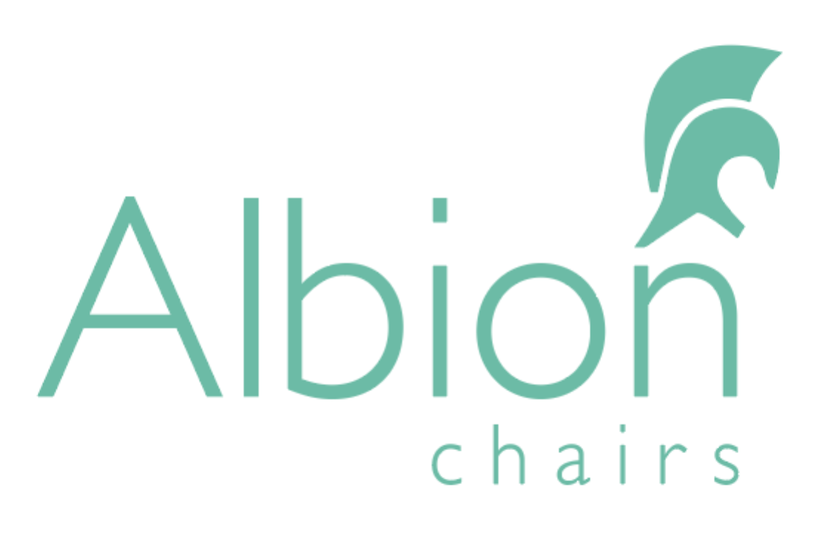
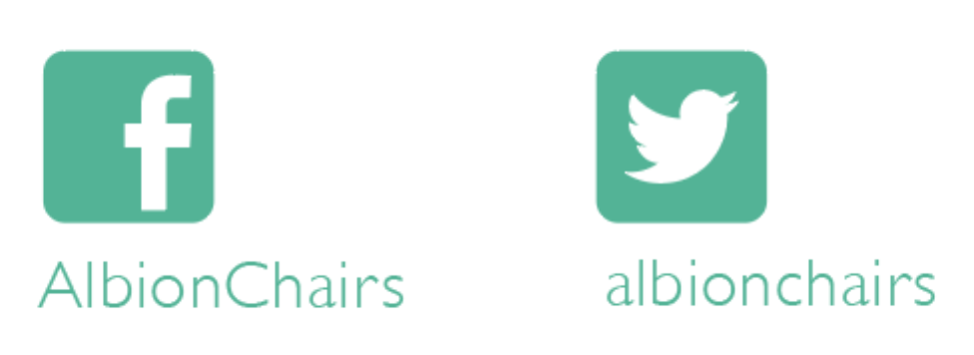
Albion Chairs Limited,
Albion House,
Lane End Road, Sands,
High Wycombe
HP12 4HG

Tel 01494 464656
Fax 01494 474760
E-mail sales@albionchairs.com
www.albionchairs.com

E. & O. E. excepted

