

providing the right arm support

**Multi-Functional Arms**

t

**A3B**

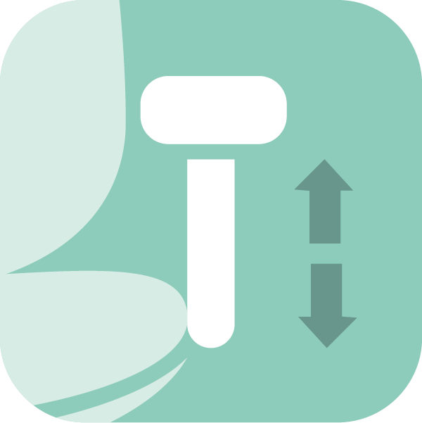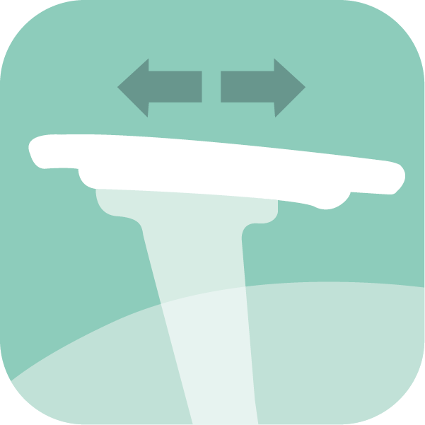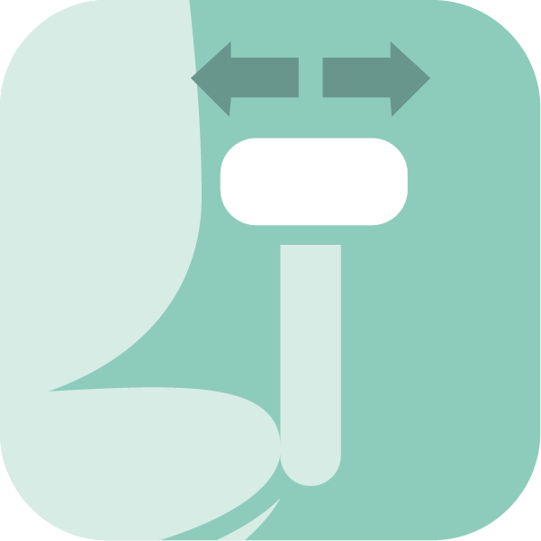

100mm height

Forward & back

Armpad width

**A5X**

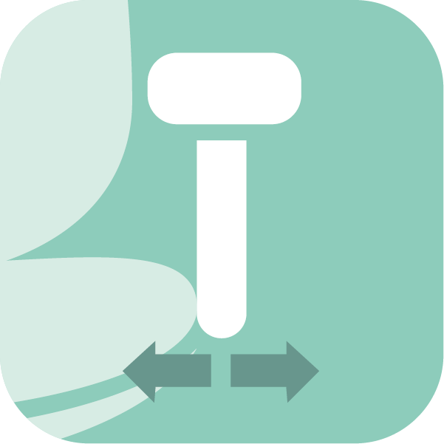

100mm height

Forward & back

Swivel

Armpad width

Arm fixing width

**FA6**



100mm height

Forward & back

Swivel

Armpad width

Arm fixing width

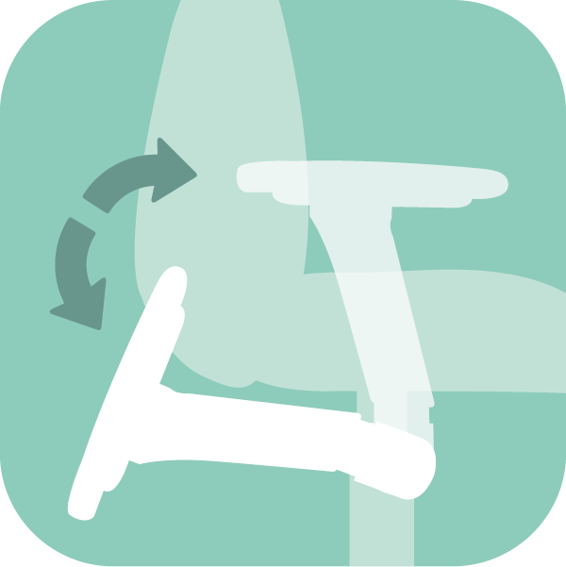

Arm fixing width

For further information, please call our sales office on **01494 464656**, or fax **01494 474760**

e-mail: sales@albionchairs.com www.albionchairs.com

**SPYNAMICS has become synonymous with ergonomic and orthopaedic seating in the workplace since 1999.** The result of collaboration between Albion Chairs and a leading osteopath, SPYNAMICS was developed for users with chronic bad backs. For the first time in the contract seating market, a combination of memory foam, a coccyx relief cut out, and combined pelvic and lumbar support was used. The SPYNAMICS range has continued to evolve as dealers and practitioners have provided valuable feedback and contributed to our knowledge pool. We have listened and integrated many new developments to provide a comprehensive range of back care seating solutions suitable for users of all shapes and sizes.

The standard 5-way adjustable, multifunctional arms provided with the SPYNAMICS range allow the user to find their optimum working position whether using a laptop or a desktop computer, a static or adjustable height desk. The swivel function is lockable.