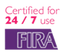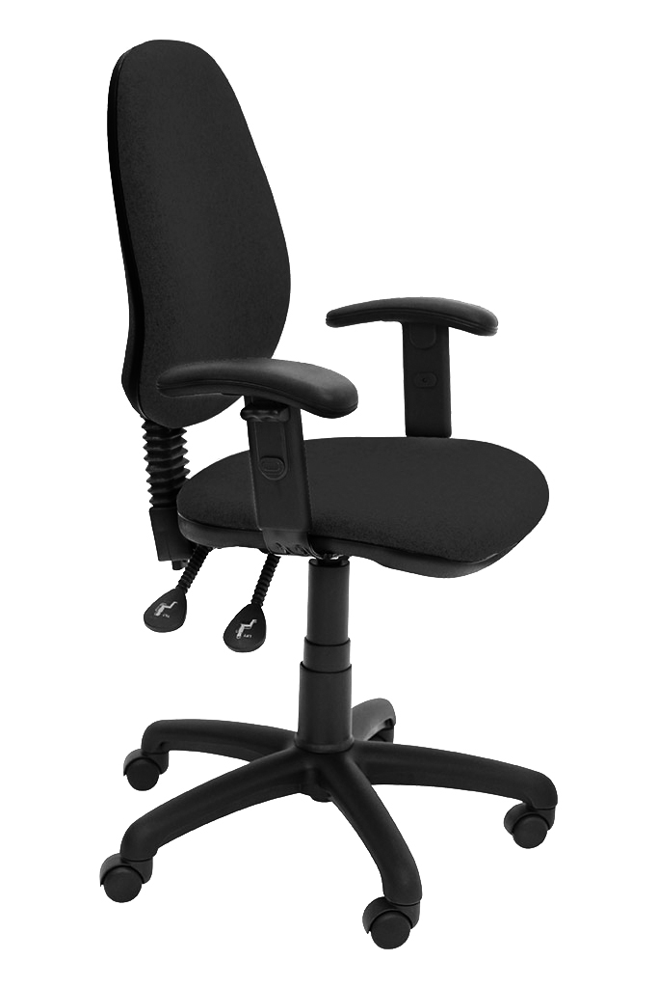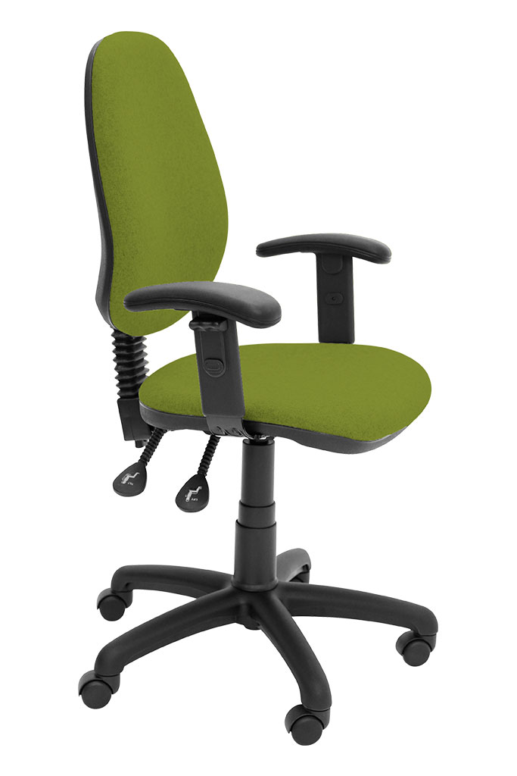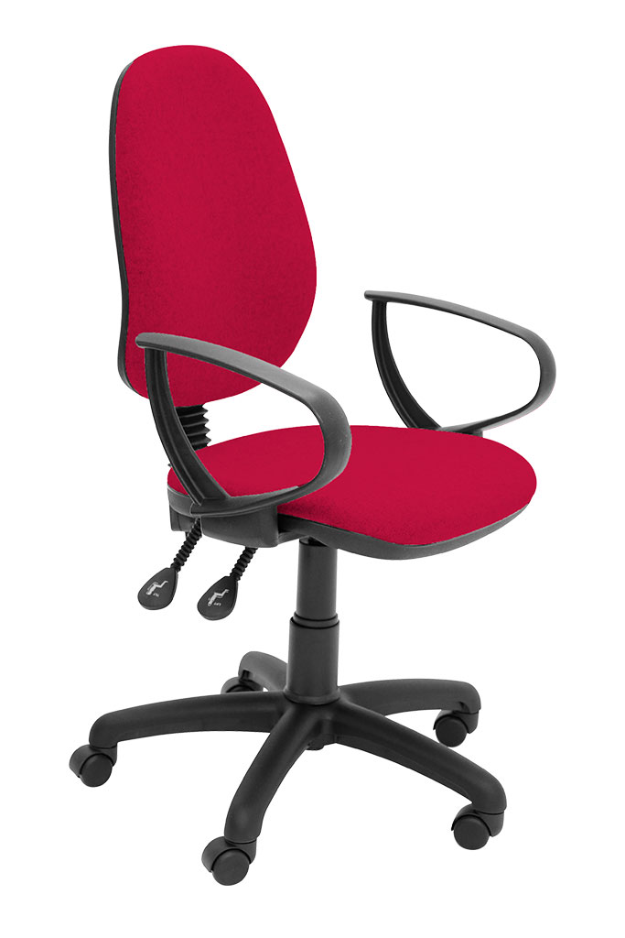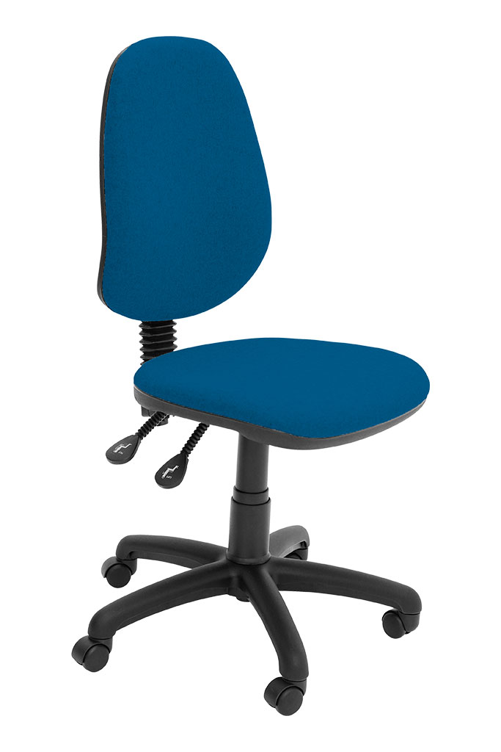­­­­

See page 17 of the Sellers’ Guide

P3

P1

P3

P2

The P range provides a compact range of operator, task seating with price in mind.

Selecting the seating is a simple case of choosing no arms or a ring or a height adjustable arm; the functionality matches the minimum VDU requirement in the workplace

We haven’t compromised on this UK manufactured chair; we still use the FIRA tested mechanical parts and it’s guaranteed for 3 years. We have made savings by reducing the options available, and by using cut foams as opposed to moulded (cold cure) foams.

If you are looking for value for money and one of our UNI Bundles or Bespoke chairs does not meet your needs, then enquire about one of the P range.

**P1 Range**

t

For further information, please call our sales office on **01494 464656**, or fax **01494 474760**

E-mail : sales@albionchairs.com www.albionchairs.com

Price-conscious Seating